Lingaya’s University



Network Lab

(IT-252)

LAB FILE

SUBMITTED TO: SUBMITTED BY:

Dr.Kamlesh Sharma  **Harshit Yadav**

14CS003

Sec-A

**EXPERIMENT-1**

**AIM: To Study about the Computer Networks**

**Introduction :**

During the twentieth century, the key technology has been information gathering, processing and distribution. Among other developments, we have seen the installation of worldwide telephone networks, the birth and unexpected growth of computer industry and the launching of communication satellites.

As we have entered in 21st century, these areas are rapidly converging. The merging of computers and communications has had a deep influence on the way computer systems are organized. The old model of a single computer serving all the organization needs, is rapidly being replaced by one in which a large number of separate but interconnected computers do the job. These systems are called computer networks.

**What is a Network?**

A network is defined as ‘an interconnected collection of autonomous computers‘. Two computers are said to be interconnected if they are capable of exchanging information. Central to this definition is the fact that the computers are autonomous. This means that no computer on the network can start, stop, or control another.

**Categories of Network :**

There are basically three types of networks:-

1. LAN (Local Area Network)
2. MAN(Metropolitan Area Network)
3. WAN(Wide Area Network)

**LAN -**

A computer network spanned inside a building and operated under single administrative system is generally termed as Local Area Network (LAN). Usually, LAN covers an organization’ offices, schools, colleges or universities. Number of systems connected in LAN may vary from as least as two to as much as 16 million.

LAN provides a useful way of sharing the resources between end users. The resources such as printer, file servers, scanners, and internet are easily sharable among computers.

LANs are composed of inexpensive networking and routing equipment. It may ontains local servers serving file storage and other locally shared applications. It mostly operates on private IP addresses and does not involve heavy routing. LAN works under its own local domain and controlled centrally.

LAN uses either Ethernet or Token-ring technology. Ethernet is most widely employed LAN technology and uses Star topology, while Token-ring is rarely seen.

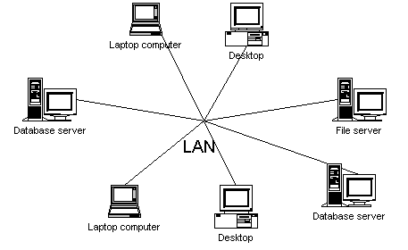

**MAN –**

The Metropolitan Area Network (MAN) generally expands throughout a city such as cable TV network. It can be in the form of Ethernet, Token-ring, ATM, or Fiber Distributed Data Interface (FDDI).Metro Ethernet is a service which is provided by ISPs. This service enables its users to expand their Local Area Networks. For example, MAN can help an organization to connect all of its offices in a city.Backbone of MAN is high-capacity and high-speed fiber optics. MAN works in between Local Area Network and Wide Area Network. MAN provides uplink for LANs to WANs or internet.

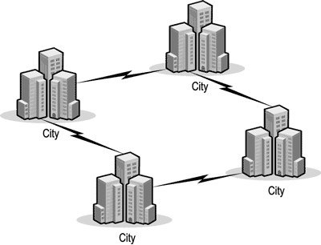

**WAN -** As the name suggests,the Wide Area Network (WAN) covers a wide area which may span across provinces and even a whole country. Generally, telecommunication networks are Wide Area Network. These networks provide connectivity to MANs and LANs. Since they are equipped with very high speed backbone, WANs use very expensive network equipment.

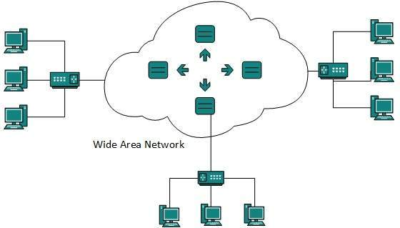

WAN may use advanced technologies such as Asynchronous Transfer Mode (ATM), Frame Relay, and Synchronous Optical Network (SONET). WAN may be managed by multiple administration.

**Distance :**

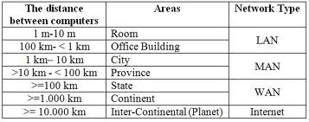

**EXPERIMENT-2**

**AIM: To Study about the CISCO Packet Tracer**

**THEORY :**

**Packet Tracer** is a cross-platform visual simulation program designed by Cisco Systems that allows users to create network topologies and imitate modern computer networks. The software allows users to simulate the configuration of Cisco routers and switches using a simulated command line interface.

Packet Tracer makes use of a drag and drop user interface, allowing users to add and remove simulated network devices as they see fit. The software is mainly focused towards Certified Cisco Network Associate Academy students as an educational tool for helping them learn fundamental CCNA concepts.

In addition to simulating certain aspects of computer networks, Packet Tracer can also be used for collaboration. As of Packet Tracer 5.0, Packet Tracer supports a multi-user system that enables multiple users to connect multiple topologies together over a computer network.

Packet Tracer also allows instructors to create activities that students have to complete. Packet Tracer is often used in educational settings as a learning aid. Cisco Systems claims that Packet Tracer is useful for network experimentation.

**OVERVIEW :**

Packet Tracer is a cross-platform network simulator designed by Cisco Systems to run on Mac OS, Linux and Microsoft Windows. A similar Android app is also available. Packet Tracer allows users to create simulated network topologies by dragging and dropping routers, switches and various other types of network devices. A physical connection between devices is represented by a "cable" item. Packet Tracer supports an array of simulated Application Layer protocols, as well as basic routing,to the extents required by the current CCNA curriculum. As of version 5.3, Packet Tracer also supports the Border Gateway Protocol

.

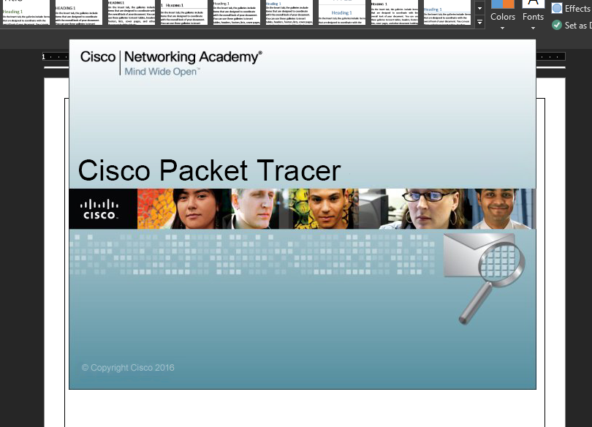

**EXPERIMENT- 3**

**AIM: To Study about the different connecting devices.**

**THEORY:**

**Hub**

A hub works in the physical layer of the OSI model. It is basically a non-intelligent device, and has no decision making capability. What a Hub basically does is take the input data from one of the ports and broadcast the information to all the other ports connected to the network.

[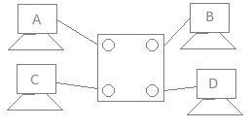](http://distortedsignal.files.wordpress.com/2011/10/1.jpg)

**Repeater**

A repeater is a device similar to the Hub, but has additional features. It also works in the Physical layer. The repeaters are used in places where amplification of input signal is necessary. But, the kind of amplification done by the repeater is different from the regular amplification by amplifiers. The regular amplifies everything fed into it. That means, if the input signal has noise induced into it, both the desired signal and noise signal are together amplified. But, in the case of a repeater, it regenerates the input signal, and amplifies only the desirable signal. Hence, the noise component of the signal is eliminated.

[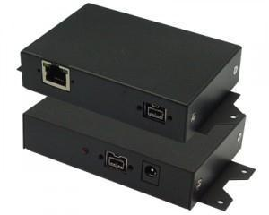](http://distortedsignal.files.wordpress.com/2011/10/3.jpg)

**Switch**

A switch is an intelligent device that works in the data link layer. The term intelligent refers to the decision making capacity of the Switch. Since it works in the Data link layer, it has knowledge of the MAC addresses of the ports in the network.

[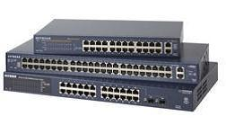](http://distortedsignal.files.wordpress.com/2011/10/4.jpg)

**Bridge**

A bridge is also a device which works in the Data Link Layer, but is more primitive when compared to a switch. Initial bridges were used to connect only 2 LAN’s, but the most recent ones perform similar operation as the switches. It also works on the principle of transfer of information using the MAC addresses of the ports.

[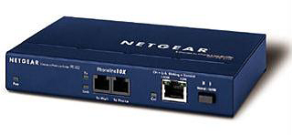](http://distortedsignal.files.wordpress.com/2011/10/5.png)

**Router**

Any computer can be connected to the internet via MODEM, which performs the MODulation and the DEModulation operations. But, when there are more than one computer at home or in an organization, and you have a single internet connection, you need a Router. Router is a device which is used when multiple devices need to connect to the Internet using the same IP.

Any Internet Service Provider (ISP) provides a single IP, and especially for personal use, the IP address is assigned dynamically. This is done because, suppose, an ISP has 1000 IP addresses, it does not mean that it has 1000 customers. An ISP assumes that not all devices will be connected to the internet at the same time. Hence, when a user wants to access the internet, any IP address from the pool of IP addresses from the ISP will be assigned to connect the user to the internet.

[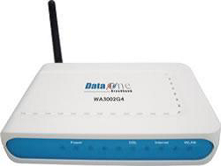](http://distortedsignal.files.wordpress.com/2011/10/6.png)

Hence, the router does the job of connecting multiple devices in a LAN to the internet using the same IP address. Since the router works in the Network Layer, it does forwarding on the basis of IP addresses.

**Gateway**

The Gateway devices work in the Transport layer and above, where the different network technologies are implemented. A gateway is necessary when there are different technologies implemented by the different LAN’s which are to be connected together.

[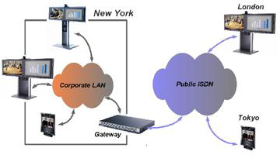](http://distortedsignal.files.wordpress.com/2011/10/7.png)

**Connecting Cables**

While connecting different networks, we come across different connecting cables, which are as follows:

1. RJ45/ RJ 11 Connectors: The RJ45 (Registered Jack 45) cable or the Cat 5 cable, is used to connect the two different LAN’s together. This is normally confused with the RJ11 cable, which is used in the interconnections in the telephone network.
2. Crossover cables: Crossover cables are generally used when 2 different computers are to be connected together. They get the name because, in these cables, a crossover is made between the Transmitter and Receiver ports, i.e., Transmitter of one end of the cable is connected to the Receiver port at the other end and vice versa.
3. Null Modem Cables: The null modem cables are also those which are used in connecting 2 different computers to form a network. They also have a crossover, but generally, the term null modem cables are used for RS232 standard cables.
4. Optical Fibres: The optical fibres are used when gigabit Ethernet is used, and very high rates of data transmission is necessary.

[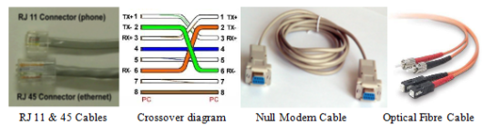](http://distortedsignal.files.wordpress.com/2011/10/8.png)

**EXPERIMENT - 4**

**Aim -: How to make a Straight Cable**

Usually use straight cable to connect different type of devices. This type of cable will be used most of the time and can be used to:

1) Connect a computer to a switch/hub's normal port.

2) Connect a computer to a cable/DSL modem's LAN port.

3) Connect a router's WAN port to a cable/DSL modem's LAN port.

4) Connect a router's LAN port to a switch/hub's uplink port. (Normally used for expanding network)

5) Connect two switches/hubs with one of the switch/hub using an uplink port and the other one using normal port.

If you need to check how straight cable looks like, it's easy. Both sides (side A and side B) of cable have wire arrangement with same color.  
Purchasing Ethernet cables can be quite expensive and pre-made lengths are not always the length you need.  Making Ethernet cables is easy with a box of bulk Category 5e Ethernet cable and RJ-45 connectors that are attached to the cut ends of your preferred cable length.

**Requisites**

* Bulk Ethernet Cable - Category 5e or CAT5e  
  (You may also use Category 6 or CAT6 cabling which has higher performance specifications and is about 20% more expensive than CAT5e.)

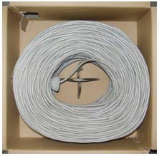 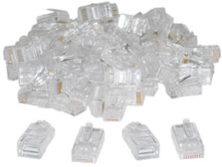

* Bulk RJ45 Crimpable Connectors for CAT-5e  
  or Bulk RJ45 Crimpable Connectors for CAT-6

* RJ-45 Crimping tool

|  |  |
| --- | --- |
|  |  |
| http://www.groundcontrol.com/galileo/images/crimper.jpg | |

**Procedure**

1. Cut into the plastic sheath about **1 inch** (2.5 cm) from the end of the cut cable. The crimping tool has a razor blade that will do the trick with practice.

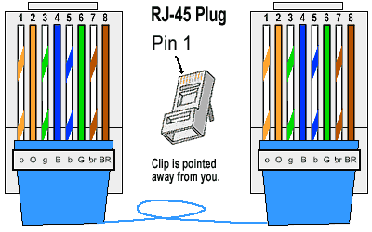

Colour Scheme for Straight Cable

1. Unwind and pair the similar colors.

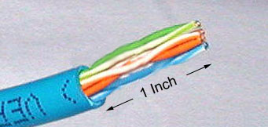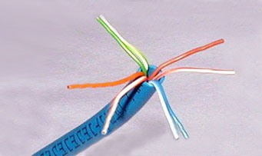

1. Pinch the wires between your fingers and straighten them out as shown. The color order is important to get correct.

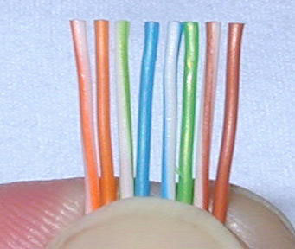

1. Use scissors to make a straight cut across the 8 wires to shorten them to **1/2 Inch** (1.3 cm) from the cut sleeve to the end of the wires.
2. CRIMPING THE CABLE ... carefully place the connector into the Ethernet Crimper and cinch down on the handles tightly. The copper splicing tabs on the connector will pierce into each of the eight wires. There is also a locking tab that holds the blue plastic sleeve in place for a tight compression fit. When you remove the cable from the crimper, that end is ready to use.

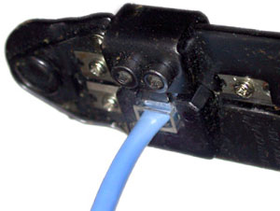

1. For a standard "Straight Through" cable, repeat all steps and wire color order on the other end of cable. For a cross-over cable, the other end will have a different color order as shown by the crossover picture above.

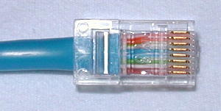 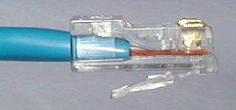

**EXPERIMENT - 5**

**Aim -: How to make a Crossover Cable**

Ethernet crossover cable. An Ethernet crossover cable is a type of Ethernet cable used to connect computing devices together directly. It is most often used to connect two devices of the same type: e.g. two computers (via network interface controller) or two switches to each other.

**Requisites**

* Bulk Ethernet Cable - Category 5e or CAT5e (You may also use Category 6 or CAT6 cabling which has higher performance specifications and is about 20% more expensive than CAT5e.)



* Bulk RJ45 Crimpable Connectors for CAT-5e or Bulk RJ45 Crimpable Connectors for CAT-6
* RJ-45 Crimping tool

|  |  |
| --- | --- |
|  |  |
| http://www.groundcontrol.com/galileo/images/crimper.jpg | |
|  | |

**Procedure**

1. Cut into the plastic sheath about **1 inch** (2.5 cm) from the end of the cut cable. The crimping tool has a razor blade that will do the trick with practice.

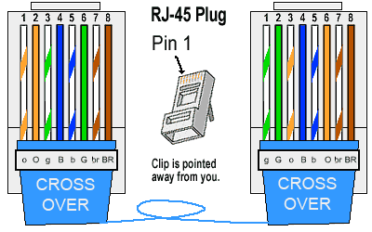

Color Scheme for Crossover Cable

1. Unwind and pair the similar colors.



1. Pinch the wires between your fingers and straighten them out as shown. The color order is important to get correct.



1. Use scissors to make a straight cut across the 8 wires to shorten them to **1/2 Inch** (1.3 cm) from the cut sleeve to the end of the wires.
2. CRIMPING THE CABLE ... carefully place the connector into the Ethernet Crimper and cinch down on the handles tightly. The copper splicing tabs on the connector will pierce into each of the eight wires. There is also a locking tab that holds the blue plastic sleeve in place for a tight compression fit. When you remove the cable from the crimper, that end is ready to use.



1. For a standard "Straight Through" cable, repeat all steps and wire color order on the other end of cable. For a cross-over cable, the other end will have a different color order as shown by the crossover picture above.

 

**EXPERIMENT- 6**

**AIM: To show connection between 2 computers using packet tracer**

**THEORY:**

**Step1 :** Move your mouse cursor to lower left corner over the PC icon. Now click on PC icon. On the window right, you will see Generic under a PC icon. Click on it and drag the mouse to main window and drop it. You will see a picture of PCO. Again click on PC icon and drag the mouse to the main window and let it go. You will see another PC1 appearing. That is you have 2 computers on the main window.

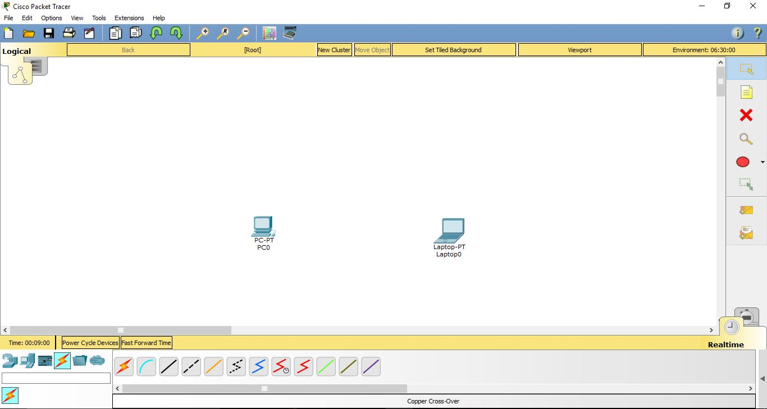

**Step2:** Now we want to connect the cables. Again lower left corner the 5th icon (zig‐zag orange in color) click on it and in box the word connections will appear. Now on the window on right you will see different types of cables appearing. Choose the first on “Automatically choose connection type”. Click on this cable and drag it from PC1 to Laptop0. Two green dots appear confirming that the connection has been successfully established.

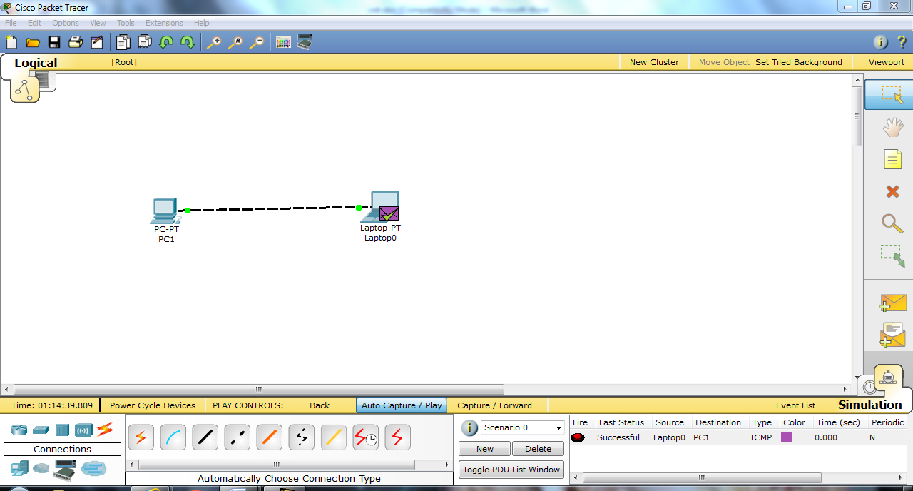

**Step3:** Now that we have the simple network, we need to assign IP addresses to the 2 PCs. Fast double click on PC1. You will get pop‐up window of PC1 and click on “Config” menu to get the window below.



**Step4:** In global settings, enter the gateway – 192.168.6.1 and the click on fast ethernet on left hand column. There enter the IP address – 192.168.4.2 and then click on subnet mask. Similarly, for Laptop0 enter the gateway – 192.168.4.1 and in the fast ethernet type the IP address = 192.168.4.3.By clicking on subnet mask, it automatically shows – 255.255.255.0

**Step5:** Now that our connection is established we can test it either by sending a packet in simulation mode or by ping command. The ping utility shows if the connection between source pc and destination pc is working or not.

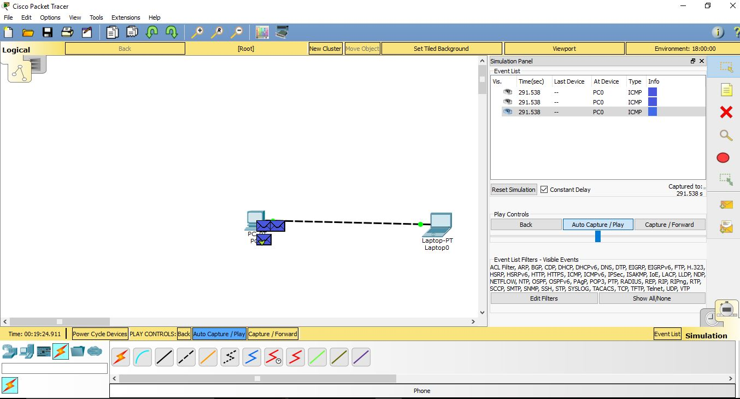

**EXPERIMENT-7**

**AIM :**

**Explain and implement different types of topologies.**

The physical topology of a network refers to the configuration of cables, computers, and other peripherals. Physical topology should not be confused with logical topology which is the method used to pass information between workstations.

The choice of topology is dependent upon:

* type and number of equipment being used
* planned applications and rate of data transfers
* required response times
* cost

**Types of Physical Topologies:**

* Bus
* Ring
* Star
* Tree
* Mesh

## Considerations When Choosing a Topology

* **Money**. A linear bus network may be the least expensive way to install a network; you do not have to purchase concentrators.
* **Length of cable needed**. The linear bus network uses shorter lengths of cable.
* **Future growth**. With a star topology, expanding a network is easily done by adding another concentrator.
* C**able type**. The most common cable in schools is unshielded twisted pair, which is most often used with star topologies.

**Bus Topology**

A linear bus topology consists of a main run of cable with a terminator at each end.

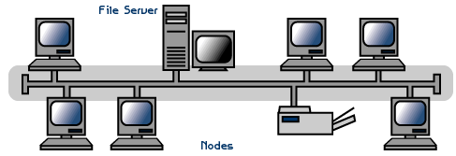

* all workstations connect to the same cable segment
* commonly used for implementing Ethernet at 10mbps
* the cable is terminated at each end
* wiring is normally done point to point
* a faulty cable or workstation will take the entire LAN down

The bus cable carries the transmitted message along the cable. As the message arrives at each workstation, the workstation computer checks the destination address contained in the message to see if it matches it's own. If the address does not match, the workstation does nothing more.

If the workstation address matches that contained in the message, the workstation processes the message. *The message is transmitted along the cable and is visible to all computers connected to that cable.*

|  |  |
| --- | --- |
| Advantages | Disadvantages |
| Easy to implement | Limits on cable length and Workstation numbers |
| Low Cost | Difficult to isolate network faults |
|  | A cable fault affects all workstations |
|  | As the number of workstations increase, the speed of the network slows down |

**Physical Implementation of a bus network:**

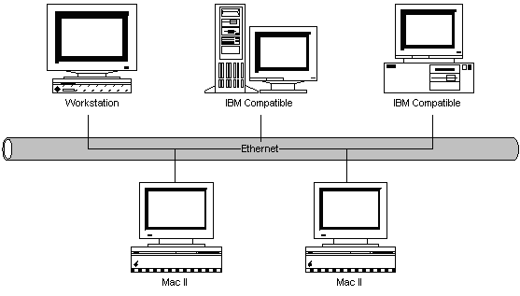

the above diagram shows a number of computers connected to a Bus cable, in this case, implemented as Thin Ethernet. Each computer has a network card installed, which directly attaches to the network bus cable via a T-Connector.

It is becoming common to use 10BaseT (UTP) for implementing Ethernet LANS. Each workstation is wired in star fashion back to a concentrator wiring centre (hub). The hub is a multi-port device supporting up to about 32 ports. One of these ports is connected to a server, or the output of the hub can be connected to other hubs.

**Procedure**

1. Move your mouse cursor to lower left corner over the PC icon. Now click on PC icon. On the window right, you will see Generic under a PC icon. Click on it and drag the mouse to main window and drop it. You will see a picture of PCO. Put 3 Generic PC’s. Similarly put 3 Switches in the network.

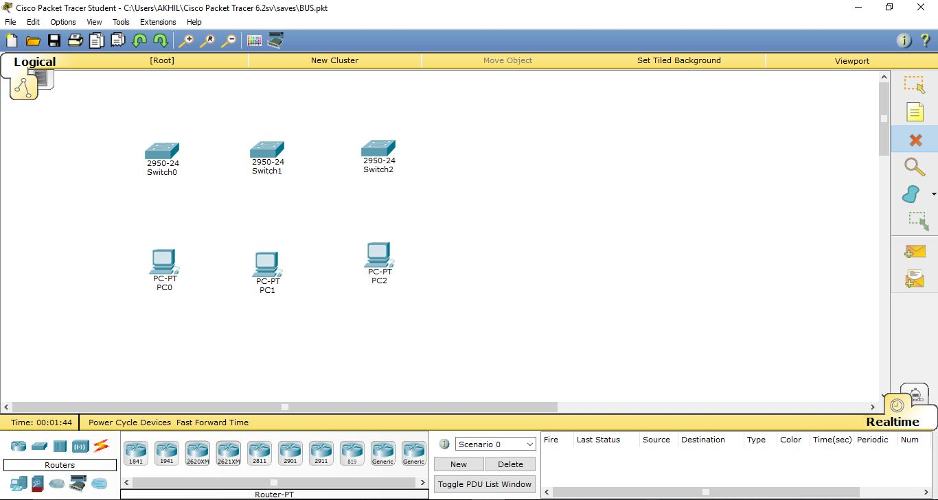

1. Now we want to connect the cables. Again lower left corner the 5th icon (zig‐zag orange in color) click on it and in box the word connections will appear. Now on the window on right you will see different types of cables appearing. Choose the first on “Automatically choose connection type”. Click on this cable and drag it from PC0 to Switch 0. Two green dots appear confirming that the connection has been successfully established. Connect all switches with each other and 1 system to each switch.

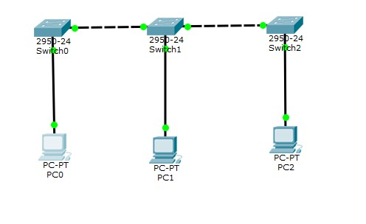

1. Now that we have the simple network, we need to assign IP addresses to the PCs. Fast double click on PC1. You will get pop‐up window of PC1 and click on “Config” menu to get the window below. Similarly, apply the IP address to all the systems.

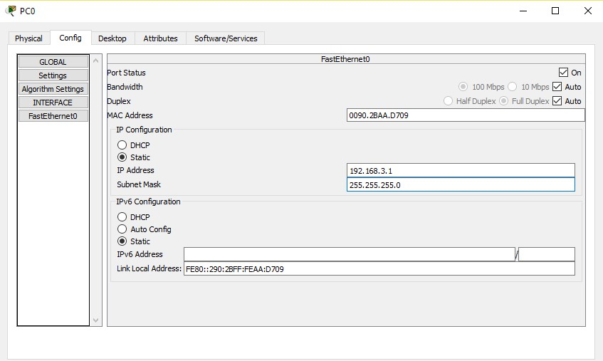

**Star Topology**

A star topology is designed with each node (file server, workstations, and peripherals) connected directly to a central network hub, switch, or concentrator (See fig. 2).

Data on a star network passes through the hub, switch, or concentrator before continuing to its destination. The hub, switch, or concentrator manages and controls all functions of the network. It also acts as a repeater for the data flow. This configuration is common with twisted pair cable; however, it can also be used with coaxial cable or fiber optic cable

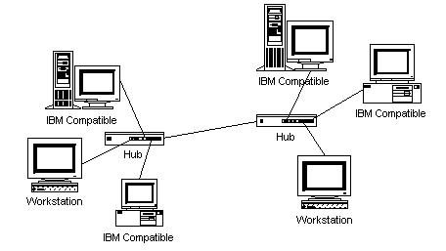

|  |  |
| --- | --- |
| Advantages | Disadvantages |
| Easy to add new workstations | Hub failure cripples all workstations connected to that hub |
| Centralized control | Hubs are slighty more expensive than thin-Ethernet |
| Centralized network/hub monitoring |  |

 Star network topology is provided by the IEEE802.15.4 layer:

Star topologies are implemented via a common switching node which routes data from one connected node to another as if it were configured as a point to point topology. From the nodes transmitting and receiving data, there is no practical distinction between a star network and a point to point network, however the inclusion of the central switch allows a network to grow to N nodes, where N is the number of leaf nodes attached to central switch.

.

**Step-1:** Make the connections as per in previous experiments

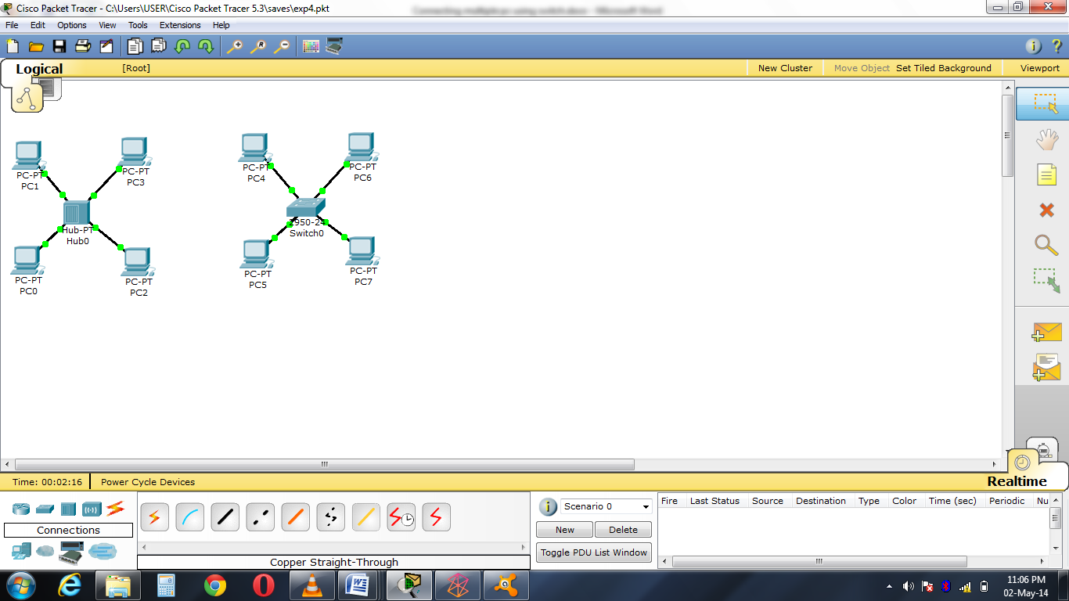

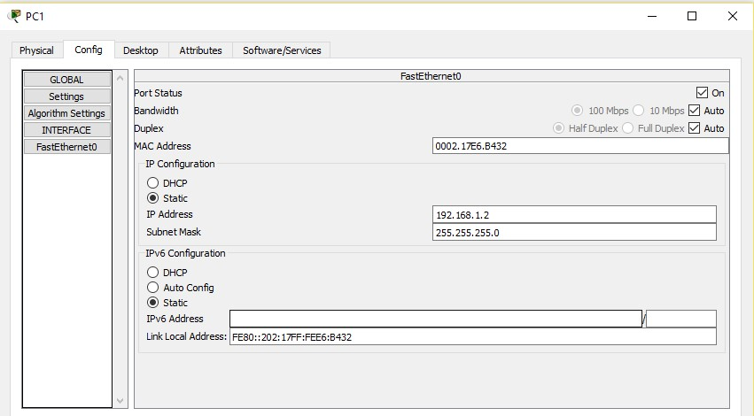

**Step-2:** Pick the simple PDU packet and drag to PC0 and then to PC2

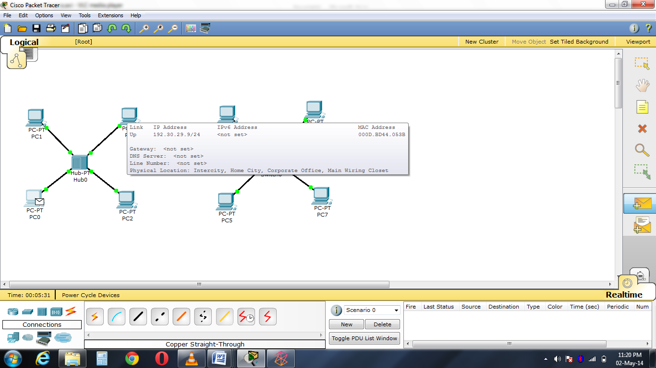

**Step 3:** Shows that Status is successful.

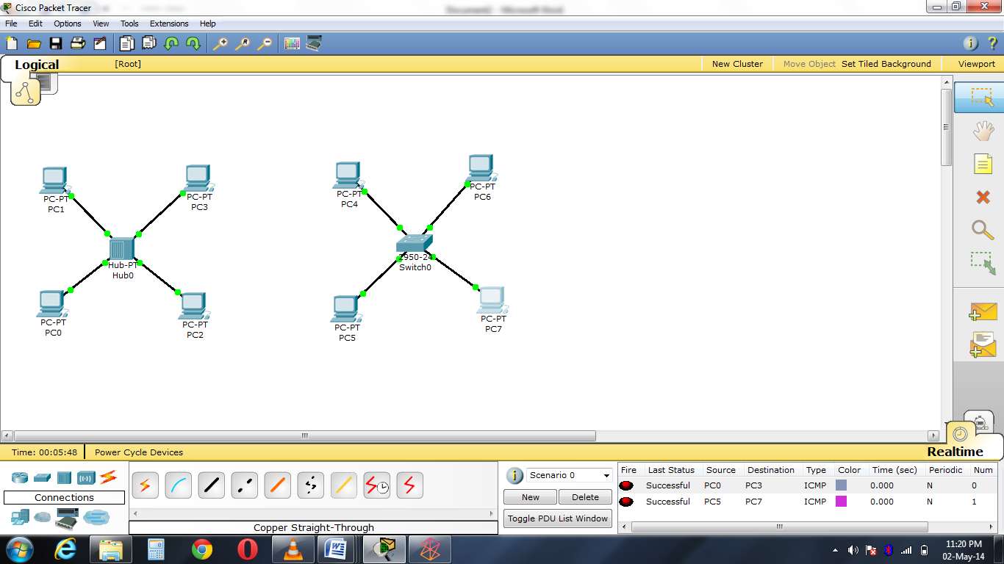

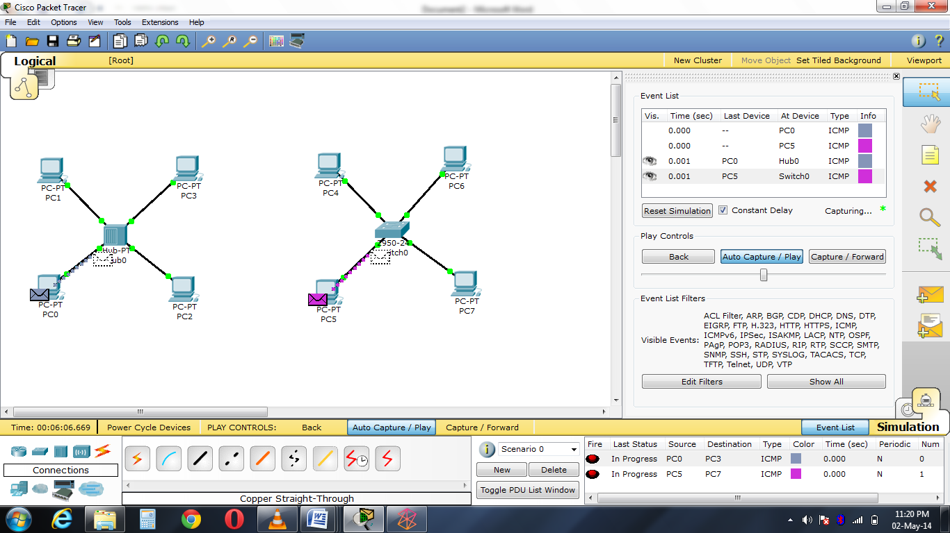**Step 4:** Play simulation mode, observe that packet is being sent from PC0 and is received by intended device.

**Ring Topology**

In a ring network, every device has exactly two neighbors for communication purposes. All messages travel through a ring in the same direction (either "clockwise" or "counterclockwise"). A failure in any cable or device breaks the loop and can take down the entire network.

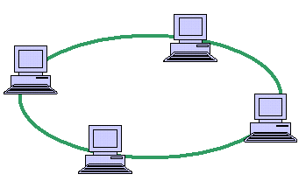

Ring topologies are found in some office buildings or school campuses.

**Physical Implementation Of A Ring Network**

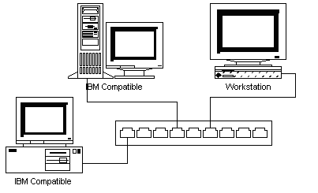  
Each workstation is connected back to a Multiple Access Unit (MAU), which supports up to eight workstations. Additional MAU are cascaded to provide greater workstation numbers.

Wiring is performed in a physical star fashion, with cables wired directly from each workstation back to the MAU.

**Step-1:** Make the connections as per in previous experiments

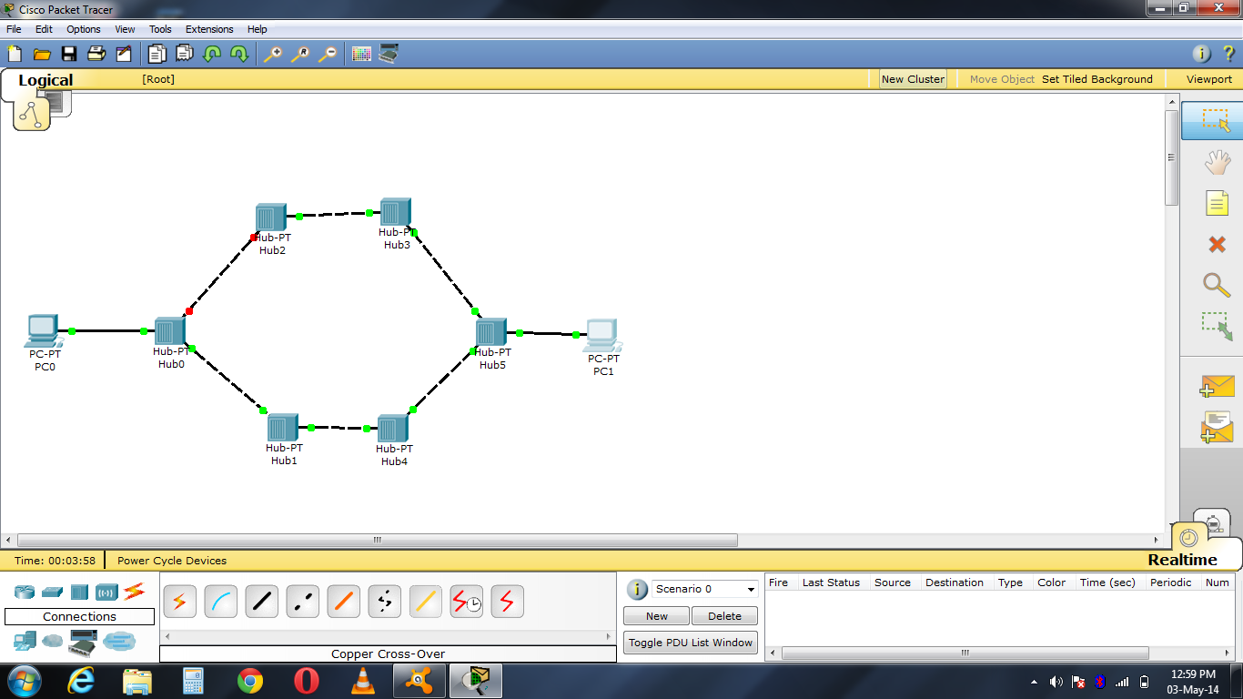

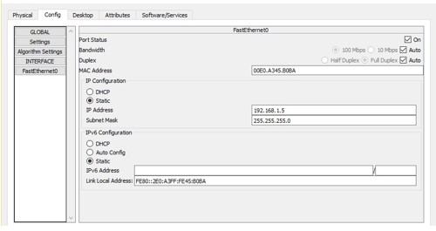

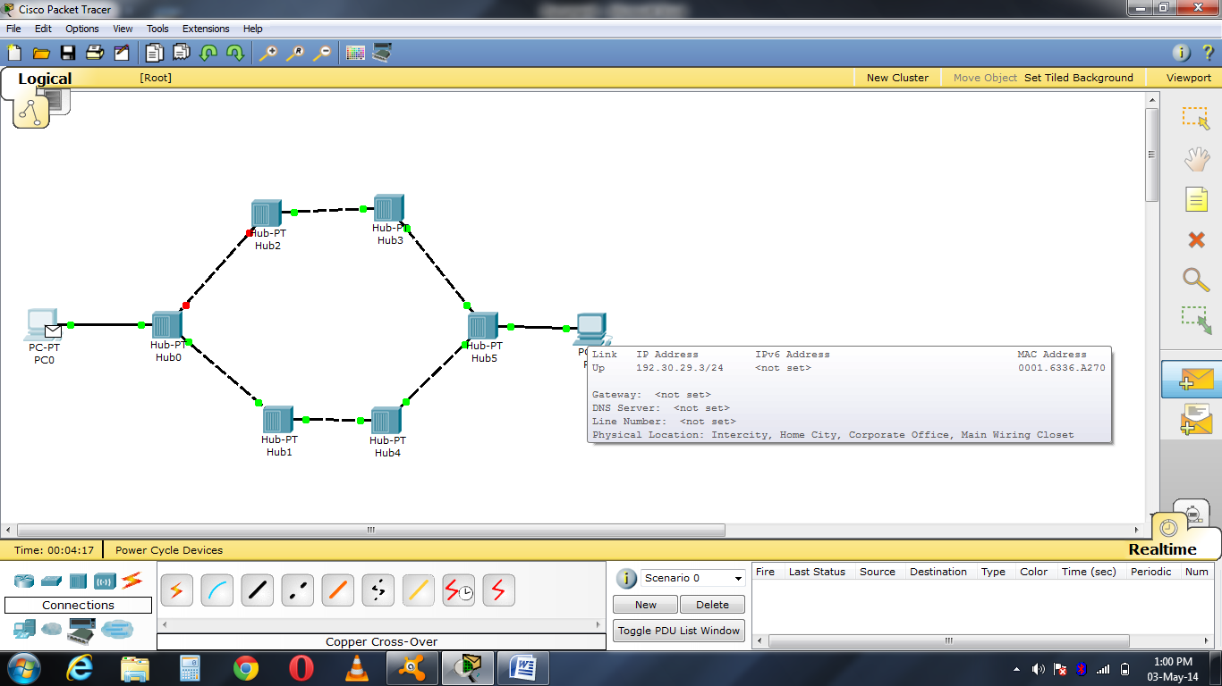**Step-2:** Pick the simple PDU packet and drag to PC0 and then to PC1

**Step 3:** Play simulation mode, observe that packet is being sent from PC0 and is received by intended device.

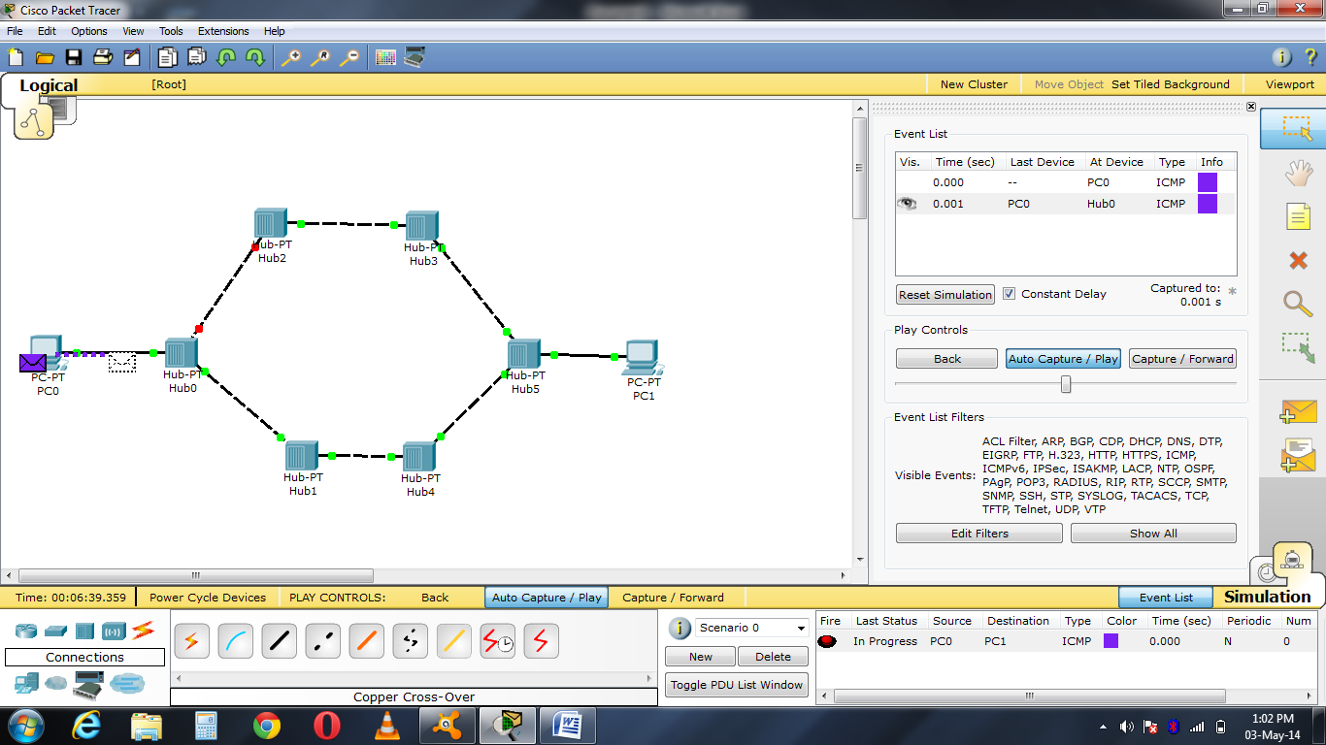

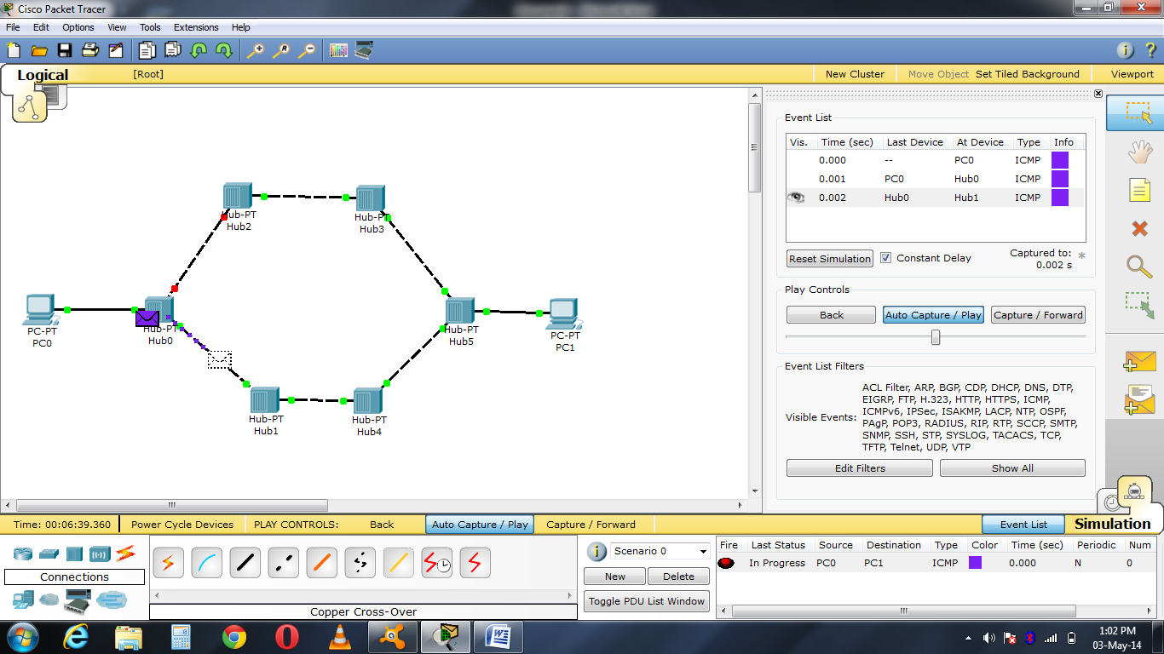

**Step 4:**

Shows that Status is successful.

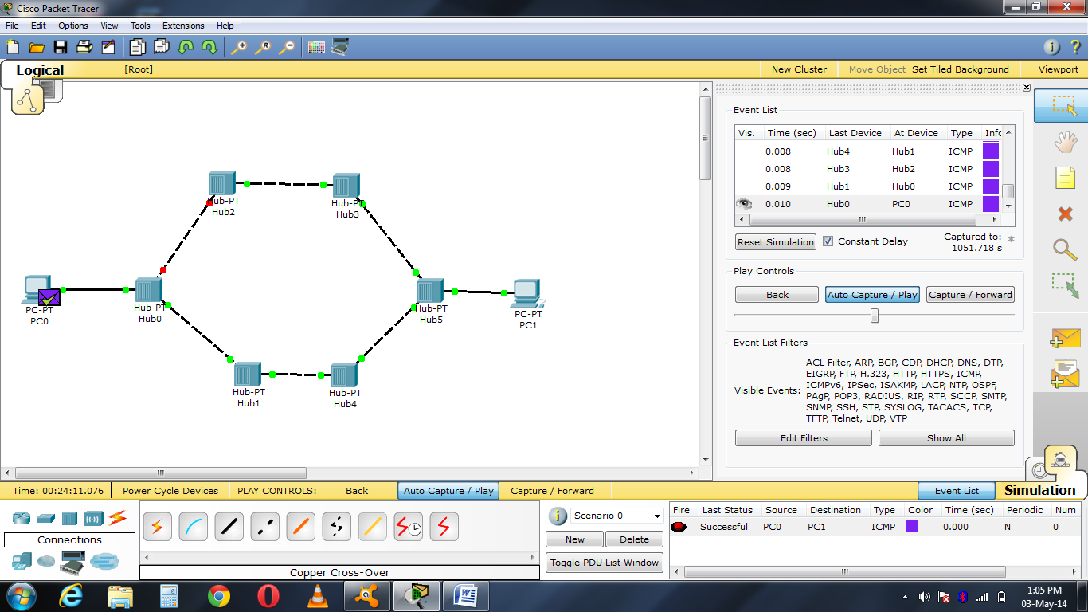

**Tree Topology:**

Tree topologies integrate multiple star topologies together onto a bus. In its simplest form, only hub devices connect directly to the tree bus, and each hub functions as the root of a tree of devices. This bus/star hybrid approach supports future expandability of the network much better than a bus (limited in the number of devices due to the broadcast traffic it generates) or a star (limited by the number of hub connection points) alone.

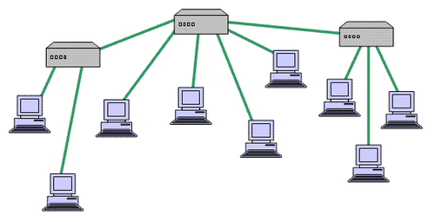

**Advantages of a Tree Topology**

* Point-to-point wiring for individual segments.
* Supported by several hardware and software venders.

**Disadvantages of a Tree Topology**

* Overall length of each segment is limited by the type of cabling used.
* If the backbone line breaks, the entire segment goes down.
* More difficult to configure and wire than other topologies.

**Procedure**

1. Move your mouse cursor to lower left corner over the PC icon. Now click on PC icon. On the window right, you will see Generic under a PC icon. Click on it and drag the mouse to main window and drop it. You will see a picture of PCO. Put 7 Generic laptops in the network. also put 3 Switches in the network.

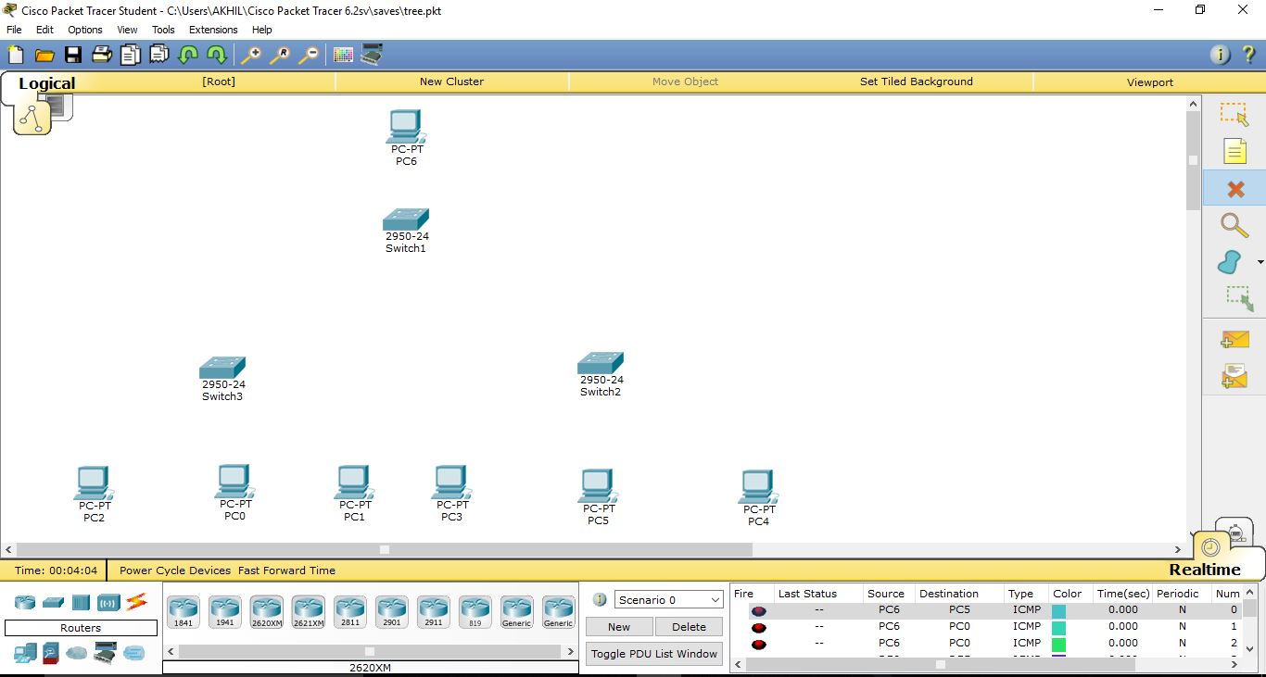

1. Now we want to connect the cables. Again lower left corner the 5th icon (zig‐zag orange in color) click on it and in box the word connections will appear. Now on the window on right you will see different types of cables appearing. Choose the first on “Automatically choose connection type”. Select this cable and connect PC0 to a Switch 1, making PC0 the parent system. Connect Switch 2 and 3 ith Switch 1, making Switch 2 and 3 the child of Switch 1. Connect 3 systems each to Switch 2 and 3. Finally, connect Switch 2 and 3 with each other.

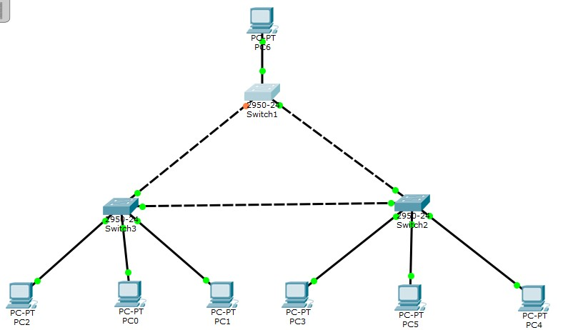

1. Now that we have the simple network, we need to assign IP addresses to the PCs. Fast double click on PC0. You will get pop‐up window of PC0 and click on “Config” menu to get the window below. Similarly, apply IP address to all the systems.

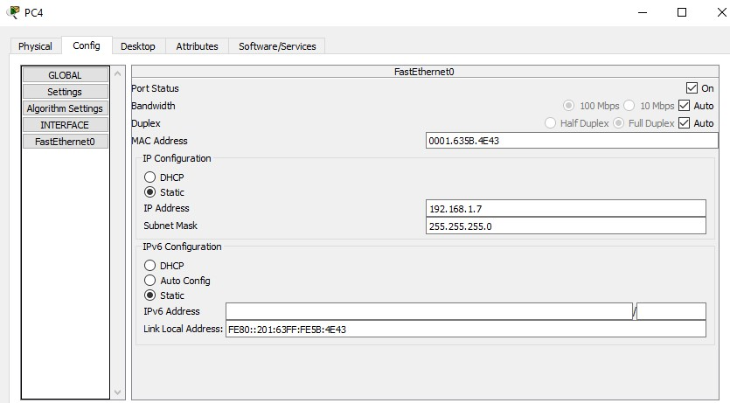

**Mesh topology**

A network setup where each computer and network device is interconnected with one another, allowing for most transmissions to be distributed, even if one of the connections go down. This topology is not commonly used for most computer networks as it is difficult and expensive to have redundant connection to every computer. However, this topology is commonly used for [wireless networks](http://www.computerhope.com/jargon/w/wifi.htm). Below is a visual example of a simple computer setup on a network using a mesh topology.

**Physical Implementation of Mesh Topology**

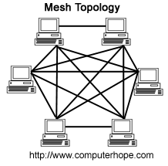

A mesh topology can be a **full mesh topology** or a **partially connected mesh topology**.

In a full mesh topology, every computer in the network has a connection to each of the other computers in that network. The number of connections in this network can be calculated using the following formula (**n** is the number of computers in the network): **n(n-1)/2**

In a partially connected mesh topology, at least two of the computers in the network have connections to multiple other computers in that network. This is a cheaper way to build a network that has some redundancy in the event one of the primary computers or connections in the network were to be down.

**Procedure**

1. Move your mouse cursor to lower left corner over the PC icon. Now click on PC icon. On the window right, you will see Generic under a PC icon. Click on it and drag the mouse to main window and drop it. You will see a picture of PCO. Put 5 Generic laptops in the network. Also put 5 Switches in the network.

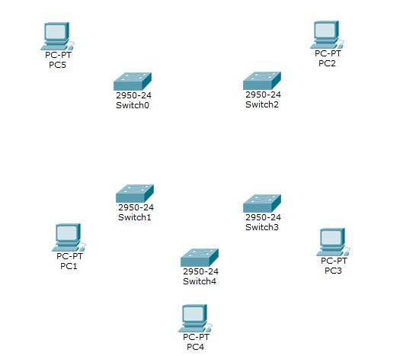

1. Now we want to connect the cables. Again lower left corner the 5th icon (zig‐zag orange in color) click on it and in box the word connections will appear. Now on the window on right you will see different types of cables appearing. Choose the first on “Automatically choose connection type”. Select this cable and connect one PC to a Switch. Similarly, connect one PC to one Switch. Now, connect every switch each other so that there is a point to point network between each Switch.

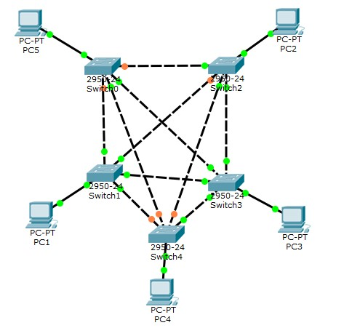

1. Now that we have the simple network, we need to assign IP addresses to the PCs. Fast double click on PC0. You will get pop‐up window of PC0 and click on “Config” menu to get the window below. Similarly, apply IP address to all the systems.

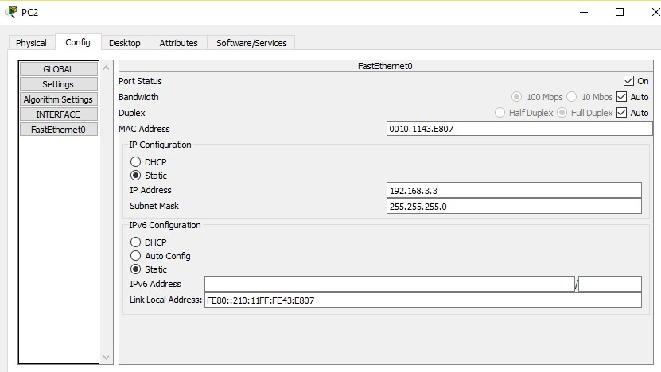

**EXPERIMENT-8**

**AIM :**

**Design a Star Tree Topology with 20 computers using Hub and Switches**

**Procedure**

1. Move your mouse cursor to lower left corner over the PC icon. Now click on PC icon. On the window right, you will see Generic under a PC icon. Click on it and drag the mouse to main window and drop it. You will see a picture of PCO. Put 7 Generic laptops in the network. also put 3 Switches in the network.

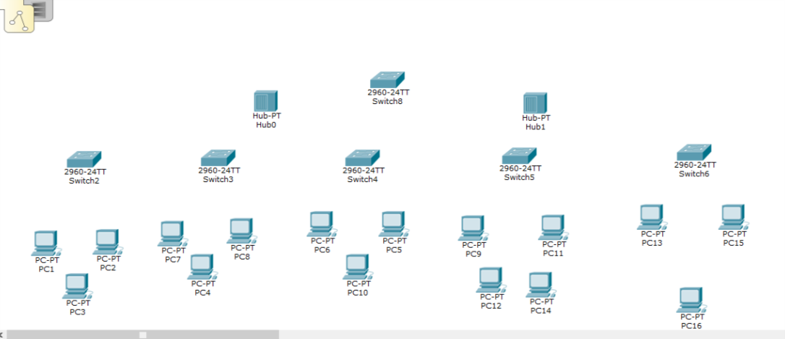

1. Now we want to connect the cables. Again lower left corner the 5th icon (zig‐zag orange in color) click on it and in box the word connections will appear. Now on the window on right you will see different types of cables appearing. Choose the first on “Automatically choose connection type”. Select this cable and connect PC0 to a Switch 1, making PC0 the parent system. Connect Switch 2 and 3 ith Switch 1, making Switch 2 and 3 the child of Switch 1. Connect 3 systems each to Switch 2 and 3. Finally, connect Switch 2 and 3 with each other.

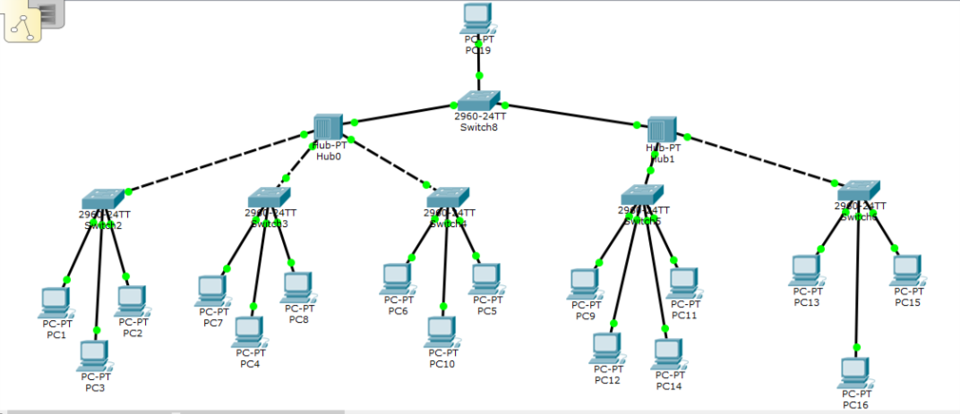

1. Now that we have the simple network, we need to assign IP addresses to the PCs. Fast double click on PC0. You will get pop‐up window of PC0 and click on “Config” menu to get the window below. Similarly, apply IP address to all the systems.



Step 3: Now Run the Simulation on the folowing topology from the Auto play and capture option in the Simulation option

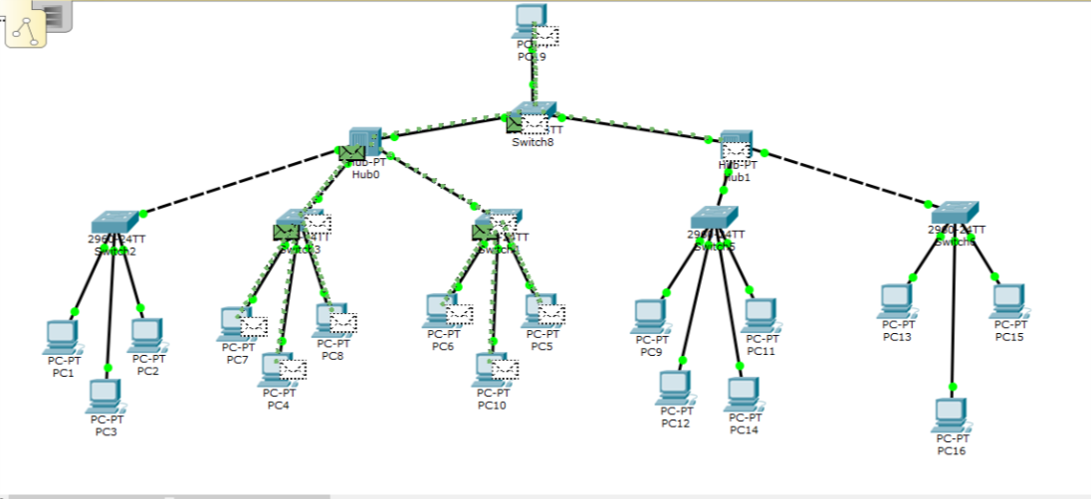

**EXPERIMENT-9**

**AIM :**

**To create a network using Ring ,Mesh , Star and bus topology**

**Procedure**

1.Move your mouse cursor to lower left corner over the PC icon. Now click on PC icon. On the window right, you will see Generic under a PC icon. Click on it and drag the mouse to main window and drop it. You will see a picture of PCO. Put 7 Generic laptops in the network. also put 3 Switches in the network.

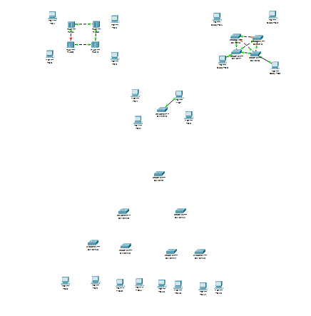

1. Now we want to connect the cables. Again lower left corner the 5th icon (zig‐zag orange in color) click on it and in box the word connections will appear. Now on the window on right you will see different types of cables appearing. Choose the first on “Automatically choose connection type”. Select this cable and connect PC0 to a Switch 1, making PC0 the parent system. Connect Switch 2 and 3 ith Switch 1, making Switch 2 and 3 the child of Switch 1. Connect 3 systems each to Switch 2 and 3. Finally, connect Switch 2 and 3 with each other.

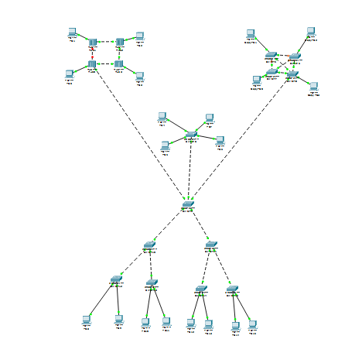

1. Now that we have the simple network, we need to assign IP addresses to the PCs. Fast double click on PC0. You will get pop‐up window of PC0 and click on “Config” menu to get the window below. Similarly, apply IP address to all the systems.



Step 3: Now Run the Simulation on the folowing topology from the Auto play and capture option in the Simulation option



**EXPERIMENT- 10**

**Aim:** **How to do static routing with the help of two routers.**

***Static routing*** is the most secure way of routing. It reduces overhead from network resources. In this type of routing we manually add routes in routing table. It is useful where numbers of route are limited.

**Step 1:** Select two computers, one server, one switch and two router, drag them on the editor.

**Step 2:** Connect pc to switch or switch to router with copper straight-through cable and connect one router to another router with serial DCE. Connect server to router with cross-over cable.

**Step 3:** Configure both the routers. And assign different IP addresses to pcs.

*Router 2 configuration*

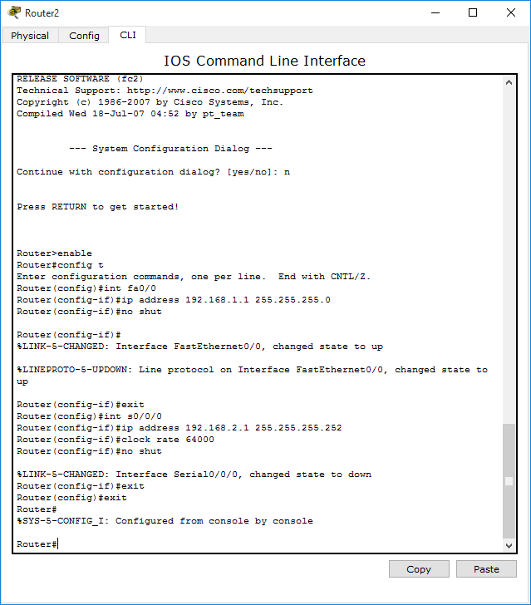

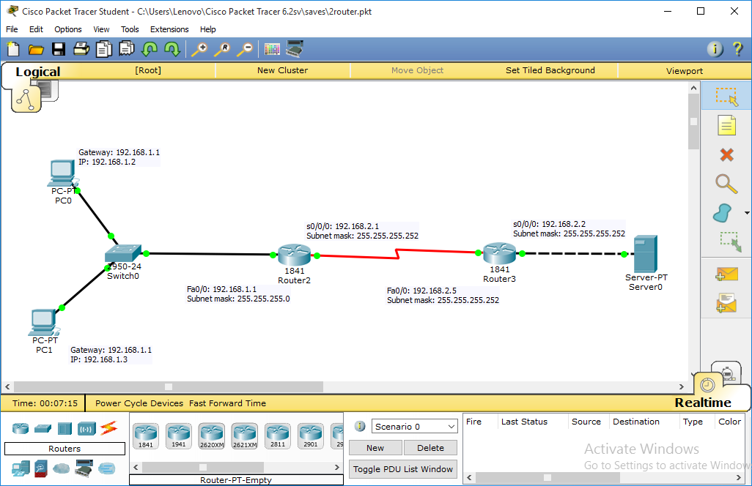

**Step 4:** Select a massages and send it from pc1 to server.

**Step 5:** Result successful as shown in fig.

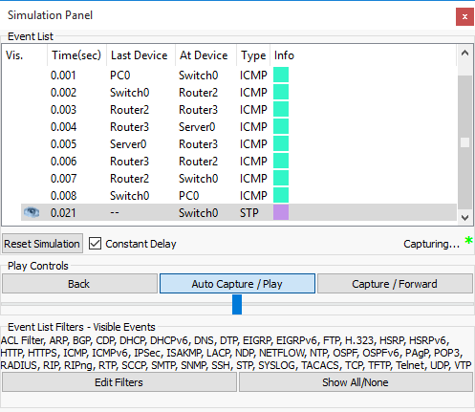

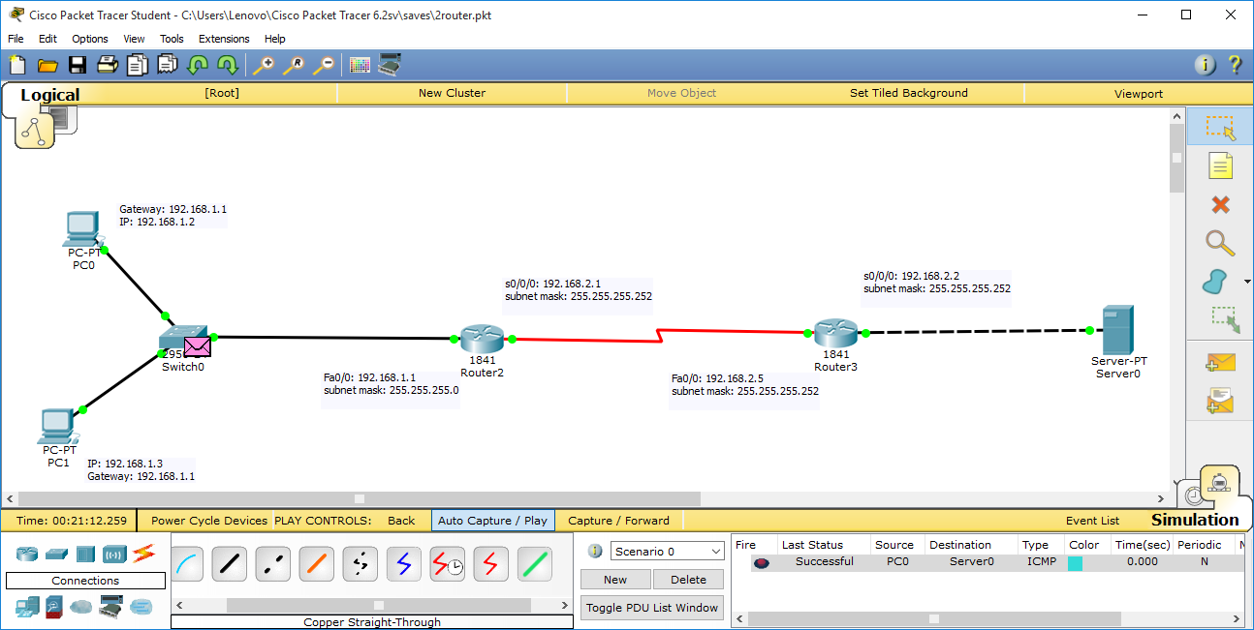

**EXPERIMENT- 11**

**Aim:** **How to do static routing with the help of three routers.**

***Static routing*** is the most secure way of routing. It reduces overhead from network resources. In this type of routing we manually add routes in routing table. It is useful where numbers of route are limited.

**Step 1:** Select two computers, one server, one switch and two router, drag them on the editor.

**Step 2:** Connect pc to switch or switch to router with copper straight-through cable and connect one router to another router with serial DCE. Connect server to router with cross-over cable.

**Step 3:** Configure both the routers. And assign different IP addresses to pcs.

*Router 1 configuration*

*Router>en*

*Router#conf t*

*Enter configuration commands, one per line. End with CNTL/Z.*

*Router(config)#int fa0/0*

*Router(config-if)#ip add 192.168.1.1 255.255.255.0*

*Router(config-if)#no shut*

*Router(config-if)#*

*%LINK-5-CHANGED: Interface FastEthernet0/0, changed state to up*

*%LINEPROTO-5-UPDOWN: Line protocol on Interface FastEthernet0/0, changed state to up*

*%IP-4-DUPADDR: Duplicate address 192.168.1.1 on FastEthernet0/0, sourced by 0090.0C3E.881D*

*Router(config-if)#int se0/0*

*%Invalid interface type and number*

*Router(config)#int se0/0/0*

*Router(config-if)#clock rate 64000*

*Router(config-if)#no shutdown*

*%LINK-5-CHANGED: Interface Serial0/0/0, changed state to down*

*Router(config-if)#int se0/0/0*

*Router(config-if)#clock rate 64000*

*Router(config-if)#ip add 192.168.2.1 255.255.255.0*

*Router(config-if)#no shutdown*

*Router(config-if)#exit*

*Router(config)#*

Router 2 Configuration :

Router>en

Router#conf t

Enter configuration commands, one per line. End with CNTL/Z.

Router(config)#int fa0/0

Router(config-if)#ip add 192.168.1.1 255.255.255.0

Router(config-if)#no shut

Router(config-if)#

%LINK-5-CHANGED: Interface FastEthernet0/0, changed state to up

%LINEPROTO-5-UPDOWN: Line protocol on Interface FastEthernet0/0, changed state to up

%IP-4-DUPADDR: Duplicate address 192.168.1.1 on FastEthernet0/0, sourced by 0090.0C3E.881D

Router(config-if)#int se0/0

%Invalid interface type and number

Router(config)#int se0/0/0

Router(config-if)#clock rate 64000

Router(config-if)#no shutdown

%LINK-5-CHANGED: Interface Serial0/0/0, changed state to down

Router(config-if)#int se0/0/0

Router(config-if)#clock rate 64000

Router(config-if)#ip add 192.168.2.1 255.255.255.0

Router(config-if)#no shutdown

Router(config-if)#exit

Router(config)#

Router 3 Configuration:

Router>en

Router#conf t

Enter configuration commands, one per line. End with CNTL/Z.

Router(config)#int fa0/0

Router(config-if)#ip add 192.168.1.1 255.255.255.0

Router(config-if)#no shut

Router(config-if)#

%LINK-5-CHANGED: Interface FastEthernet0/0, changed state to up

%LINEPROTO-5-UPDOWN: Line protocol on Interface FastEthernet0/0, changed state to up

%IP-4-DUPADDR: Duplicate address 192.168.1.1 on FastEthernet0/0, sourced by 0090.0C3E.881D

Router(config-if)#int se0/0

%Invalid interface type and number

Router(config)#int se0/0/0

Router(config-if)#clock rate 64000

Router(config-if)#no shutdown

%LINK-5-CHANGED: Interface Serial0/0/0, changed state to down

Router(config-if)#int se0/0/0

Router(config-if)#clock rate 64000

Router(config-if)#ip add 192.168.2.1 255.255.255.0

Router(config-if)#no shutdown

Router(config-if)#exit

Router(config)#

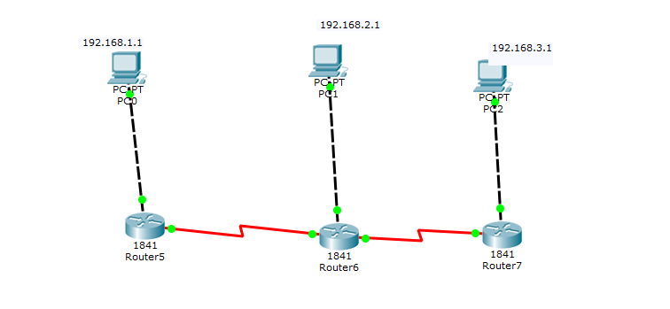

**Step 4:** Select a massages and send it from pc1 to server.

**Step 5:** Result successful as shown in fig.

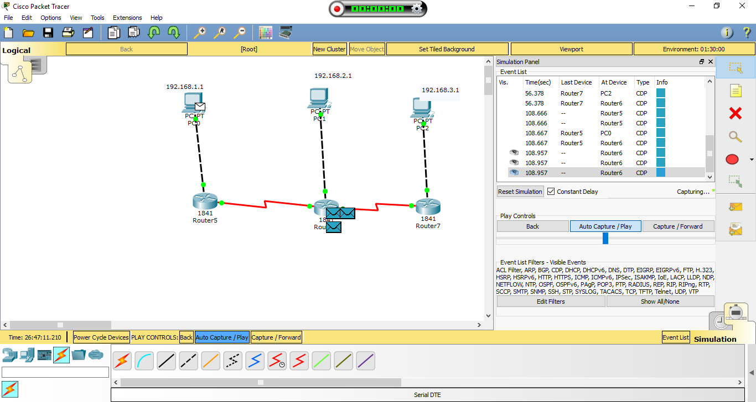

**EXPERIMENT NO. 12**

**AIM:** **To implement RIP protocol.**

**Step 1**: Take 3 Generic Routers from the Router category, 3 Generic Switches from the Switches category and 6 Generic PCs from the End devices category.

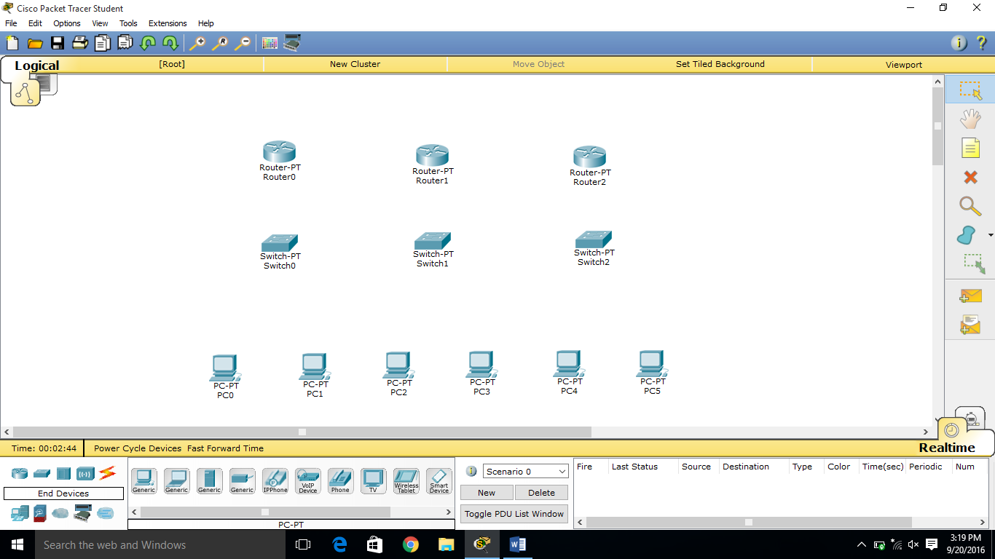

**Step 2**: Connect the routers with each other using Serial cable and with the switches using Copper Straight cable. Similarly, the switches with the generic computers using Copper Straight cable.

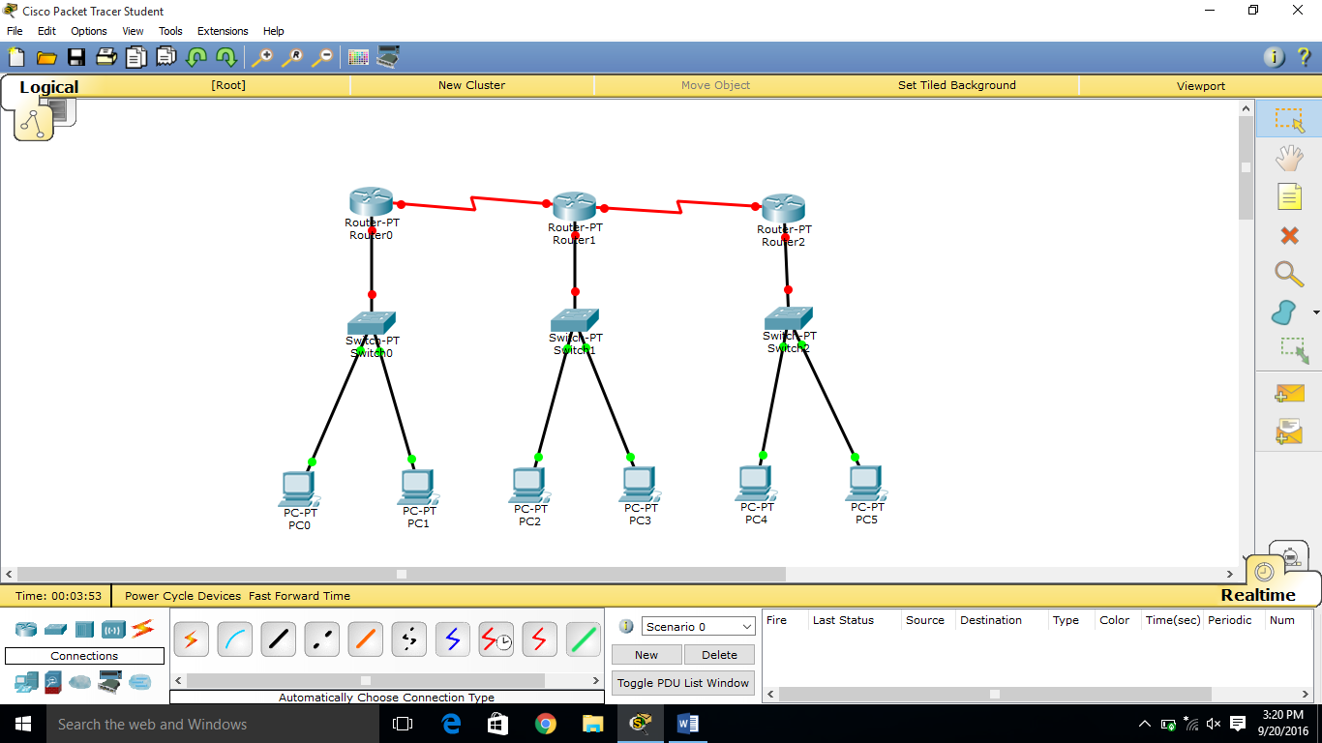

**Step 3:** Configure the three routers by clicking on the routers

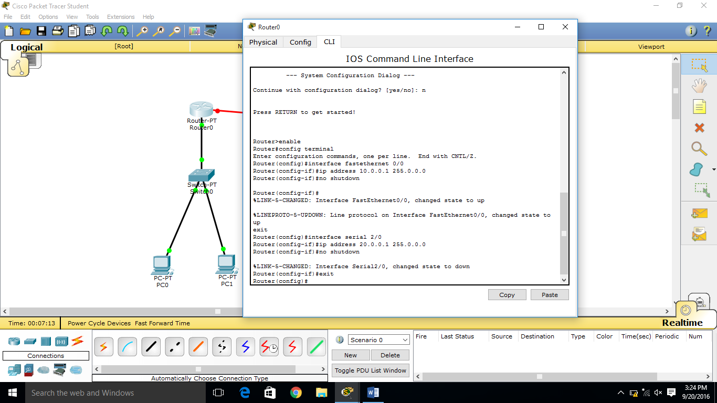 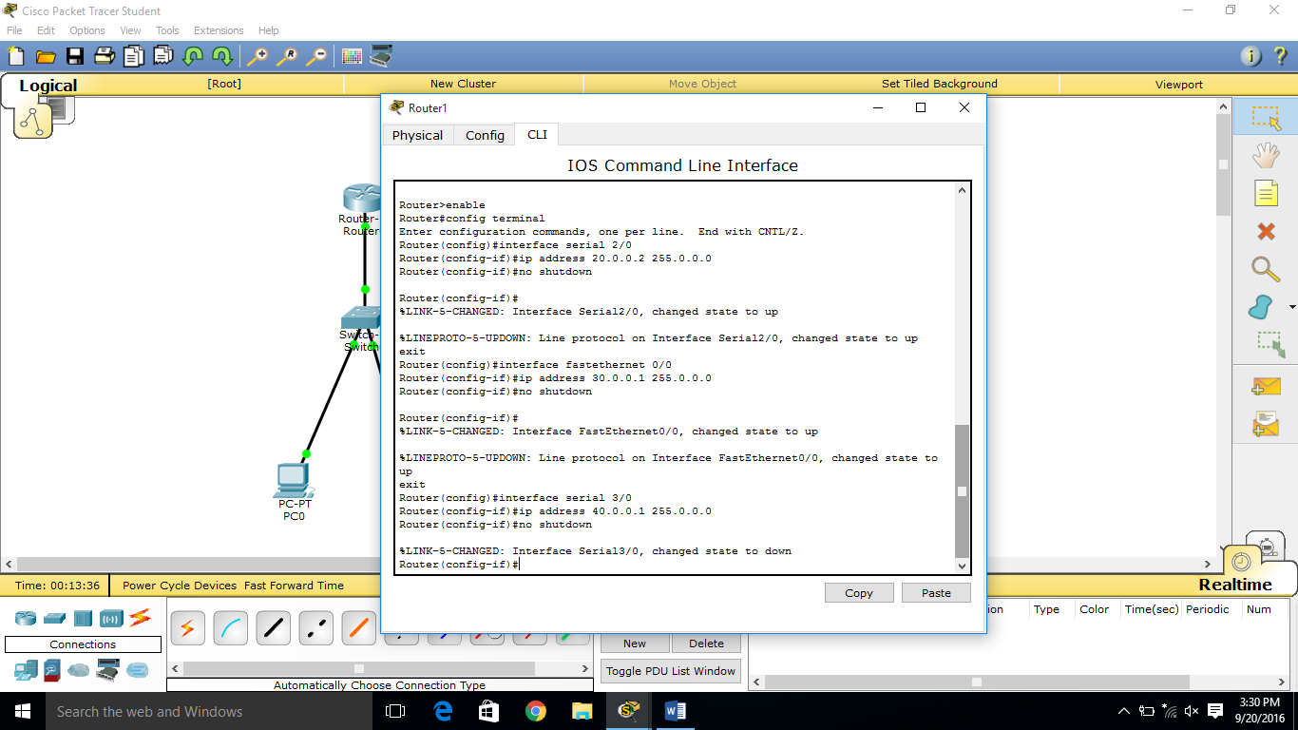

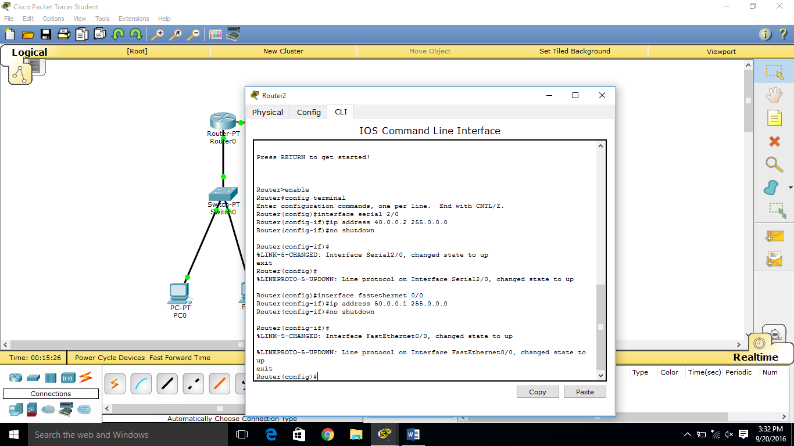

**Step 4**: Click on the PCs, then under the Desktop category choose IP Configuration, and set the IP Address along with the Subnet Mask and the appropriate Default Gateway according to the Configuration done in the router.

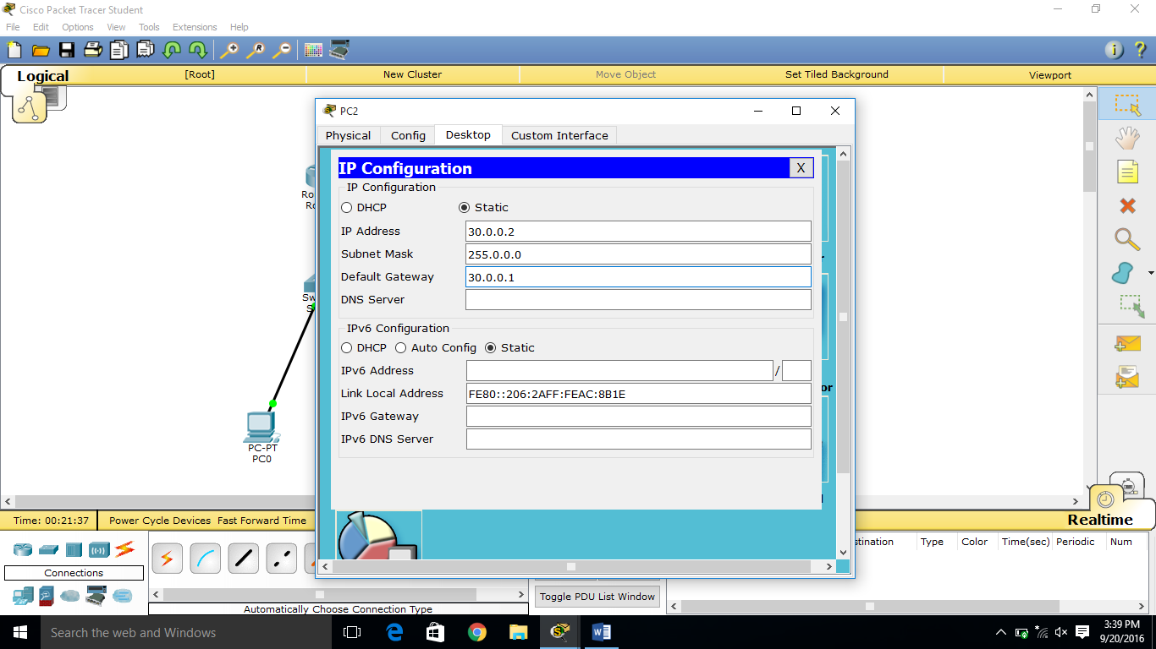 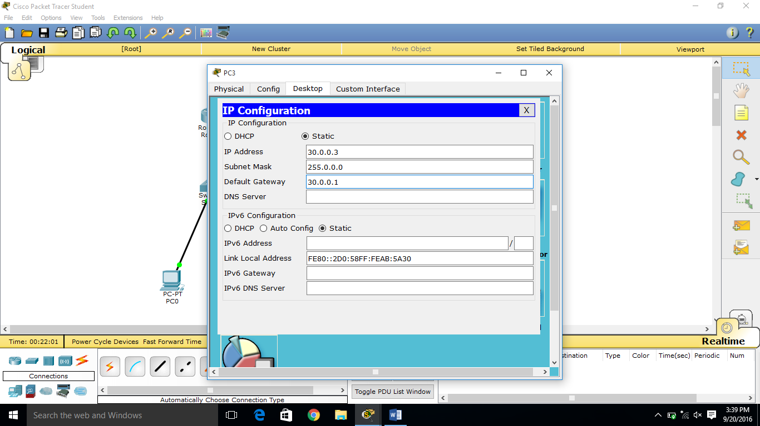

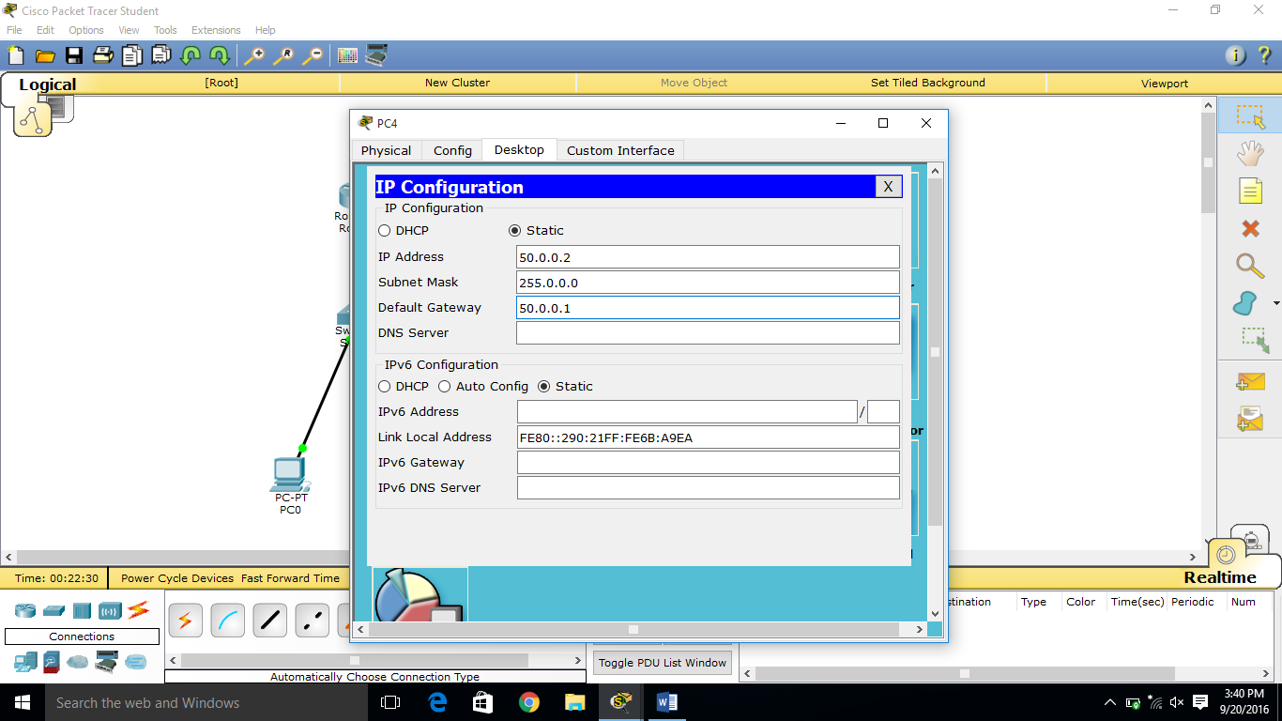 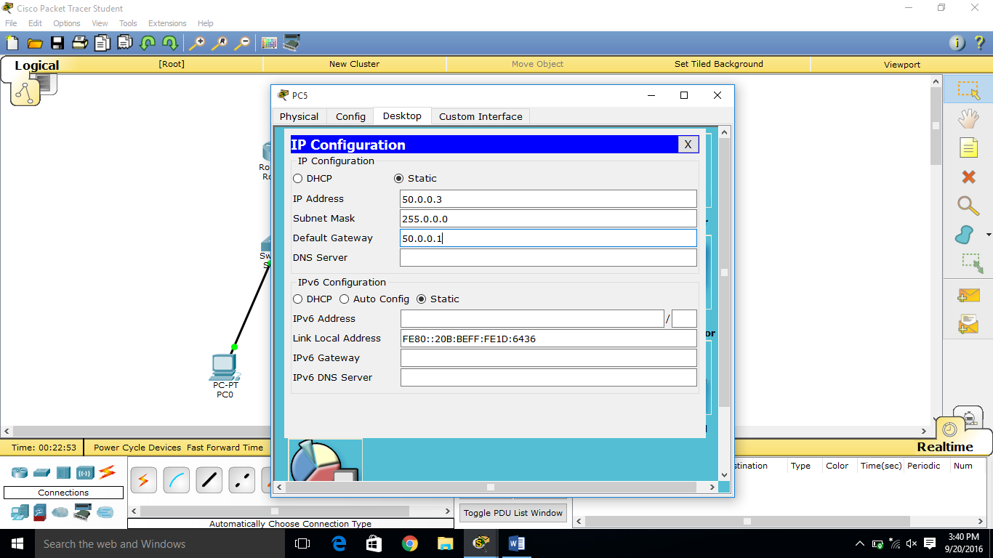

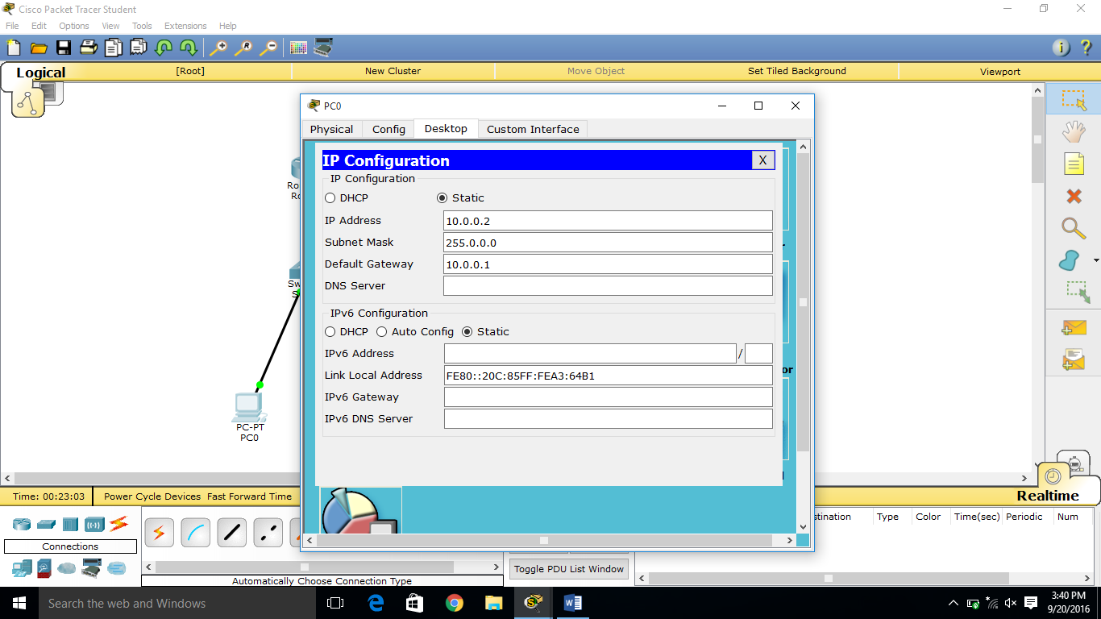 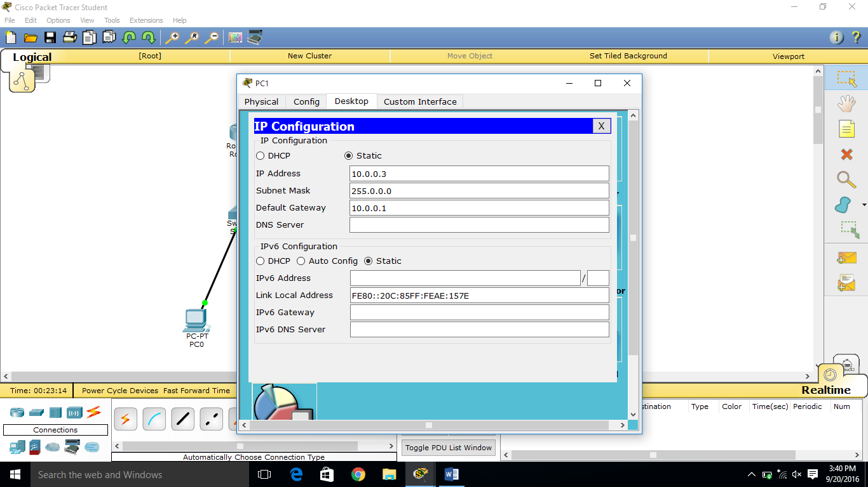

**Step 5:** Click on all the router, one at a time under CLI perform the RIP configurations.

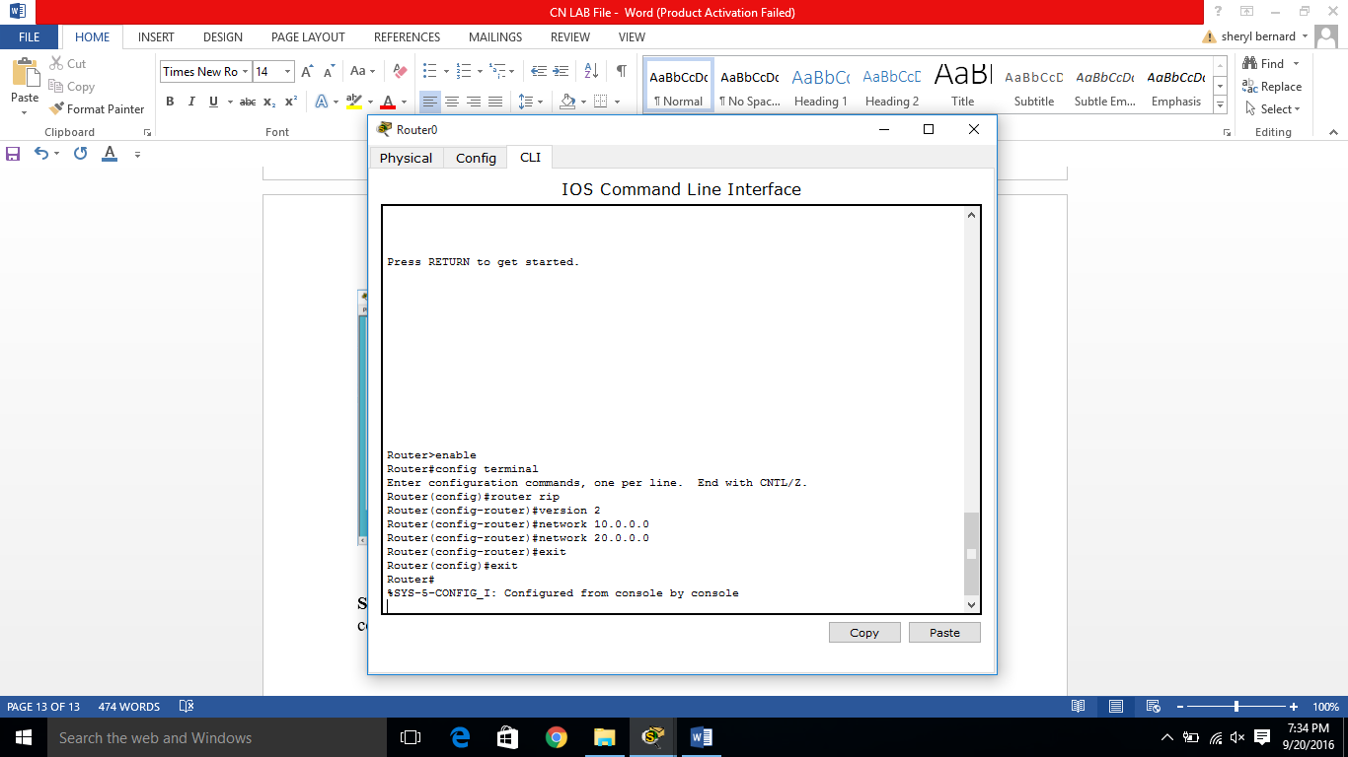 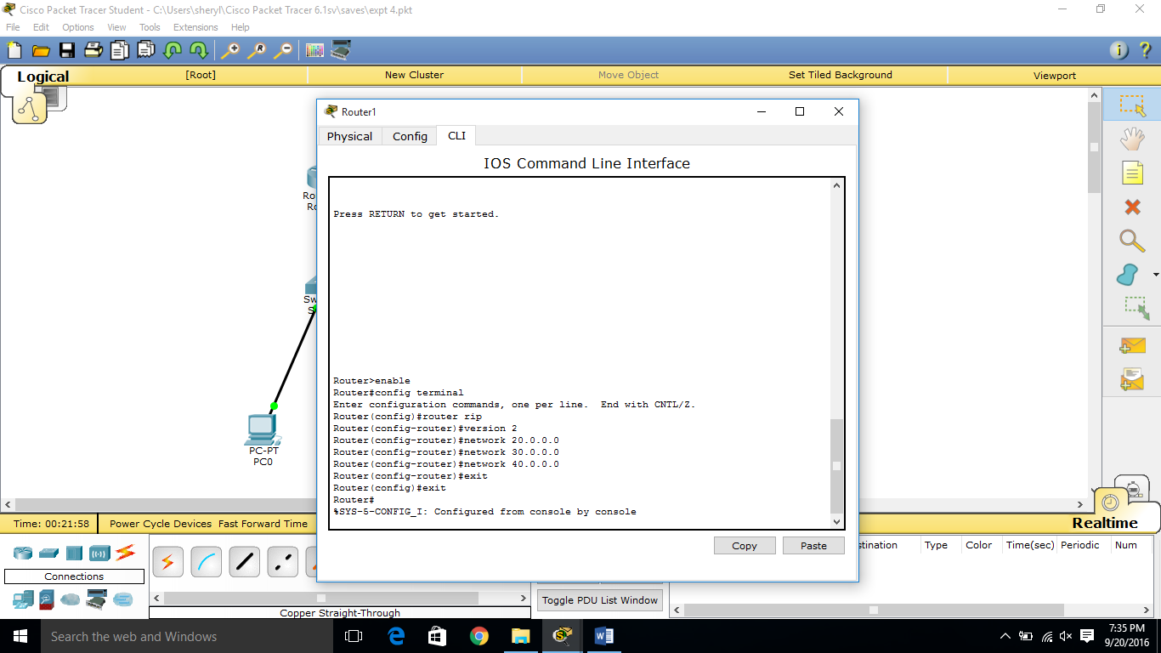

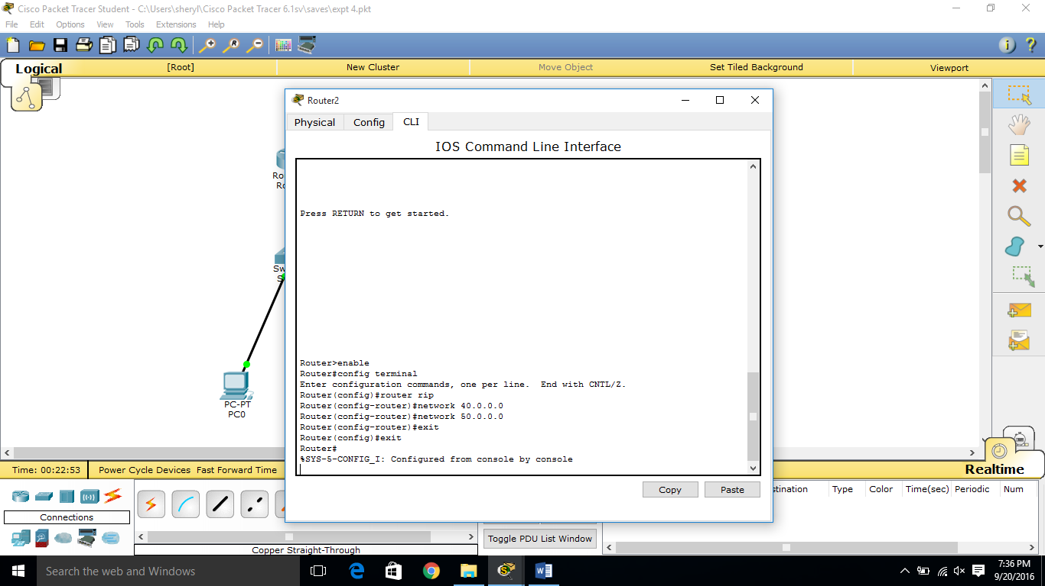

**Step 6:** Sent a message package from one PC to another. To check the connection, in the Simulation play the Auto Capture, which would show the message delivery as well as the message acknowledgment.

